<https://www.youtube.com/watch?v=Dn6b9fCIUpM&list=PLblh5JKOoLUK0FLuzwntyYI10UQFUhsY9&index=40>

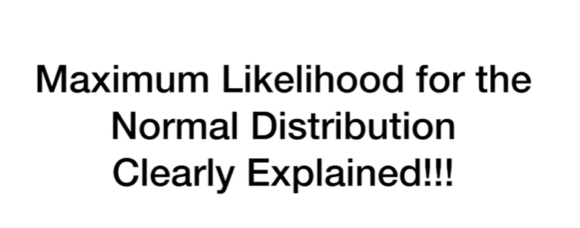

Today we're going to talk about maximum likelihood for the normal distribution and it's gonna be clearly explained.

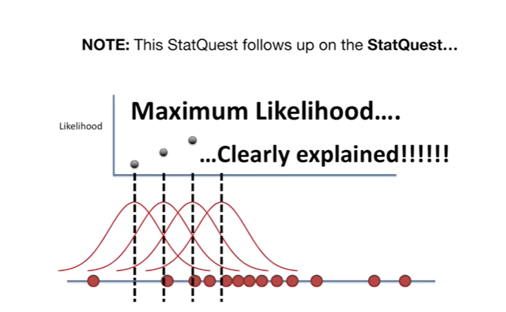

Note : this stack quest follows up on the stack quest maximum likelihood clearly explained

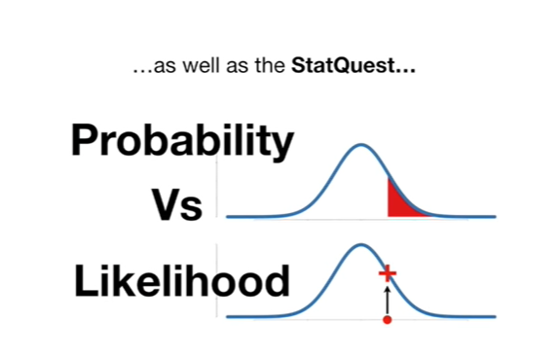

as well as the stack quest probability versus likelihood

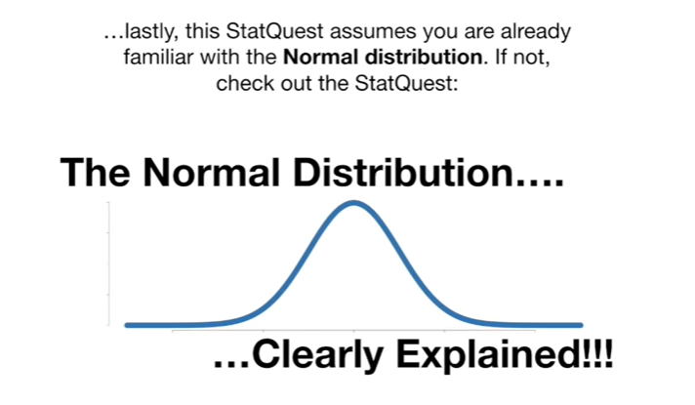

lastly this stack quest assumes you are already familiar with the normal distribution.

If not check out the stack quest the normal distribution of clearly explained.

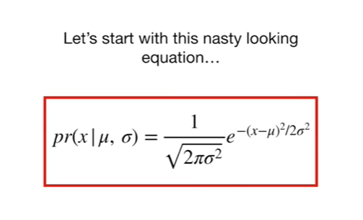

Let's start with this nasty-looking equation

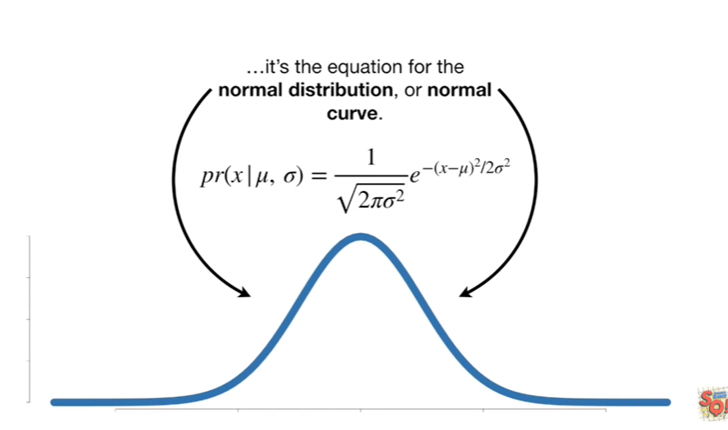

it's the equation for the normal distribution or normal curve.

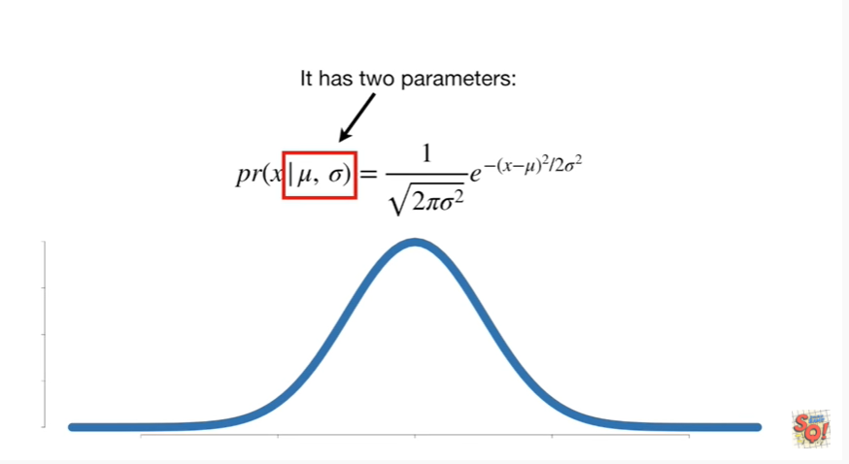

It has two parameters :

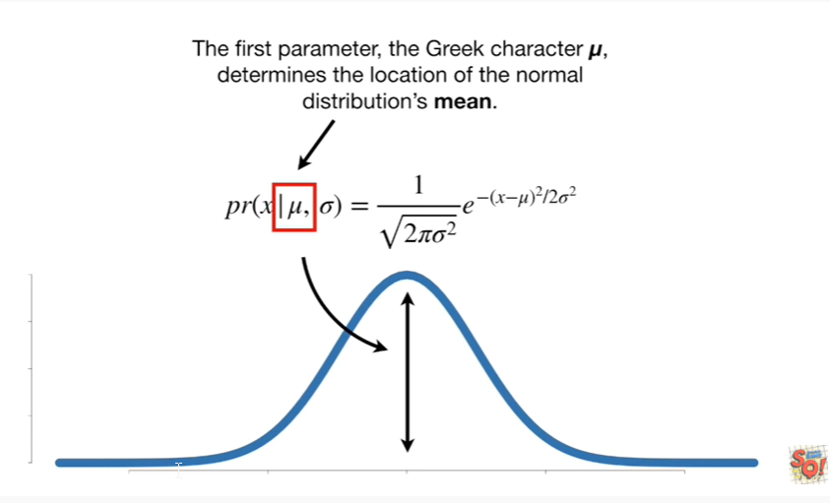

the first parameter, the Greek character mu, determines the location of the normal distribution’s mean.

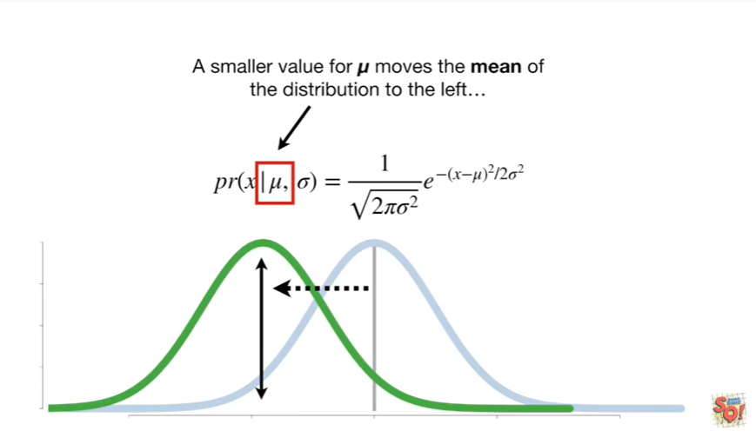

A smaller value for MU moves the mean of the distribution to the left

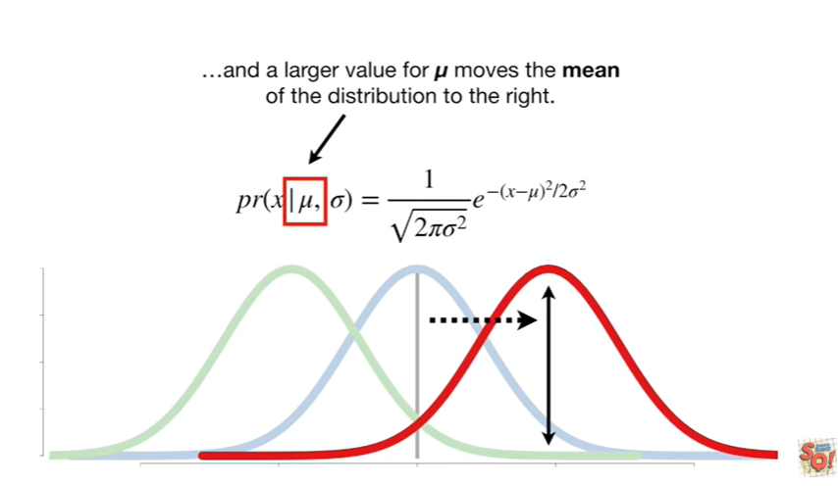

and a larger value for MU moves the mean of the distribution to the right.

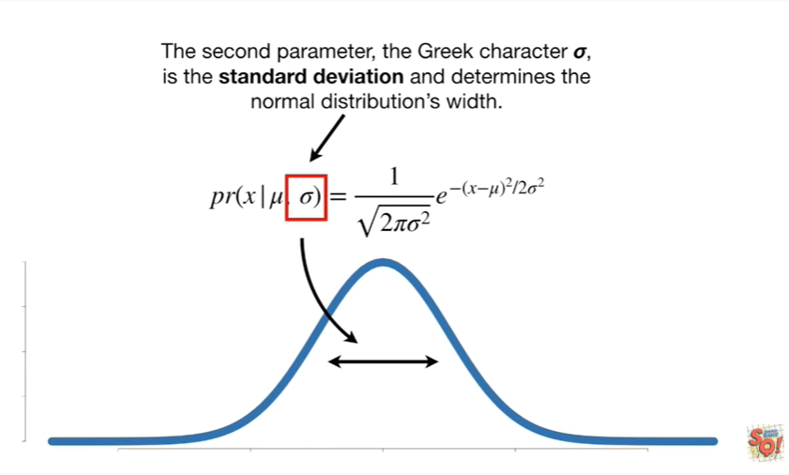

The second parameter, the Greek character Sigma, is the standard deviation and determines the normal distributions width.

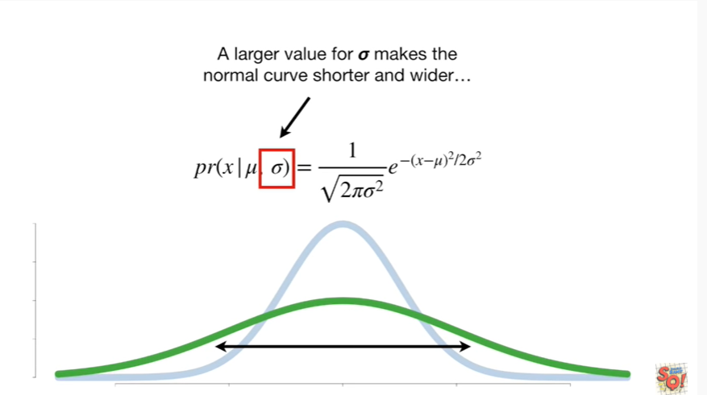

A larger value for Sigma makes the normal curve shorter and wider

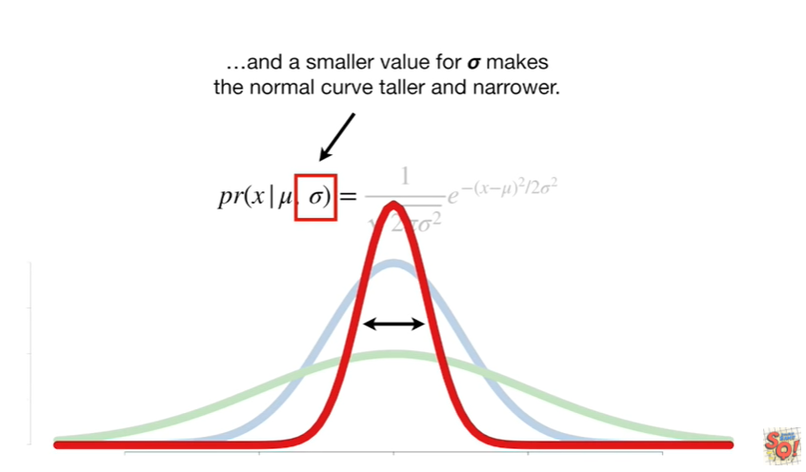

and a smaller value for Sigma makes the normal curve taller and narrower.

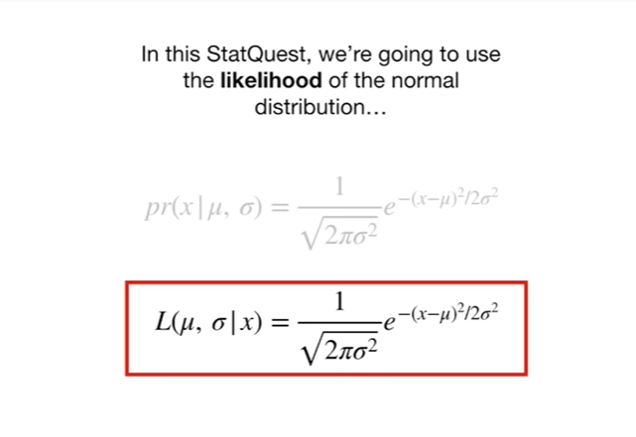

In this stat quest, we're going to use the likelihood of the normal distribution

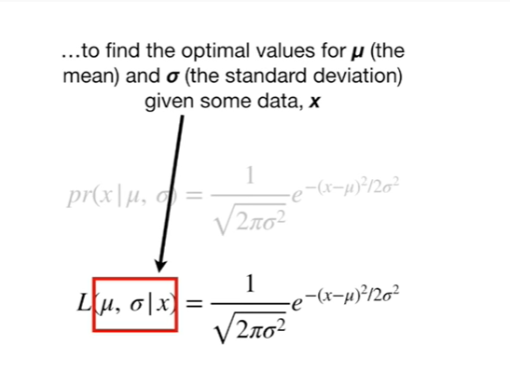

to find the optimal parameters from mu (the mean) and Sigma (the standard deviation) given some data, x.

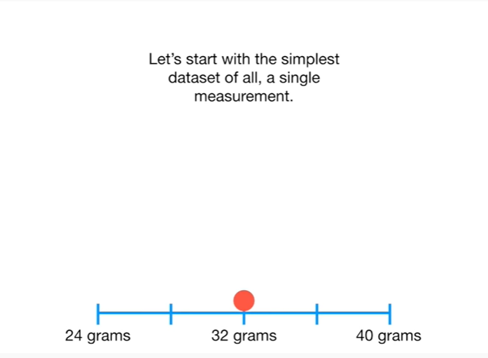

Let's start with the simplest data set of all a single measurement.

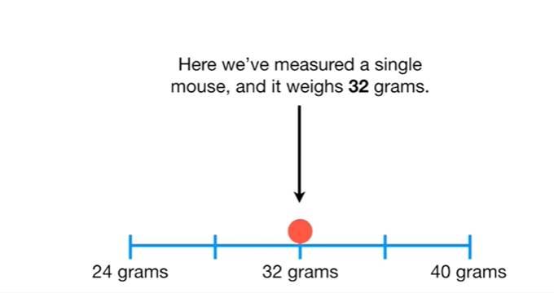

Here we've measured a single Mouse and it weighs 32 grams.

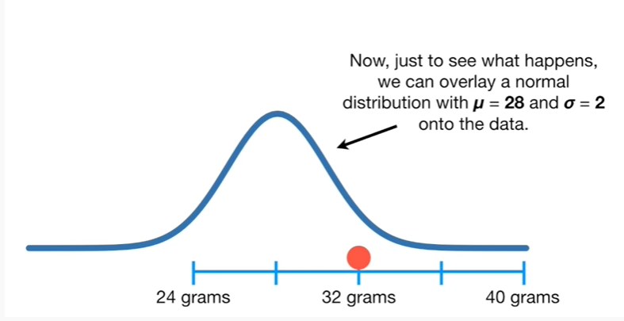

Now, just to see what happens, we can overlay a normal distribution with mu equals 28 and Sigma equals 2 onto the data.

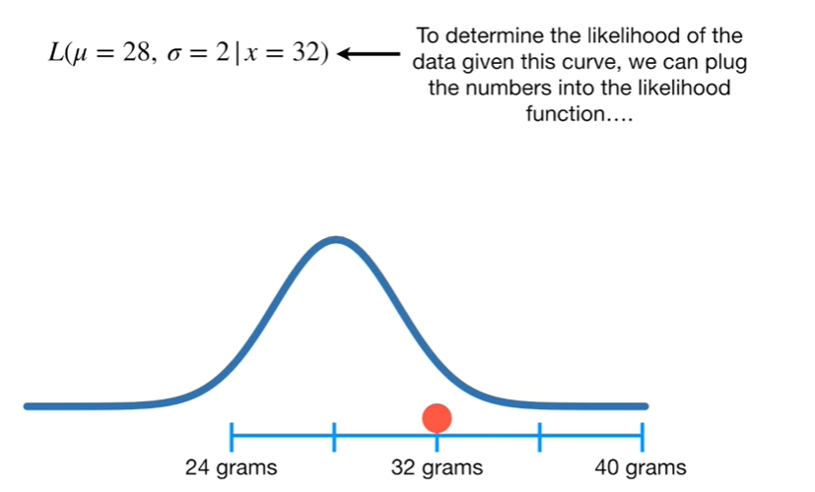

To determine the likelihood of the data given this curve we can plug the numbers into the likelihood function

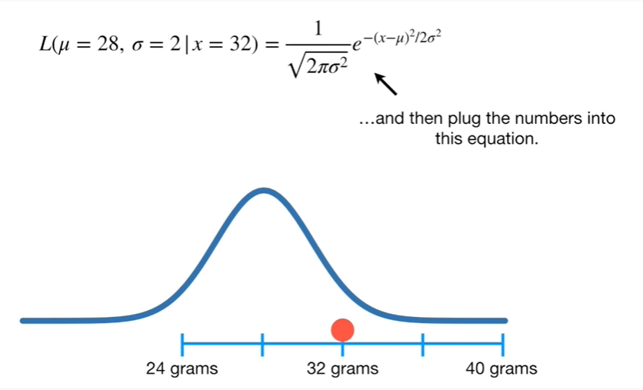

and then plug the numbers into this equation

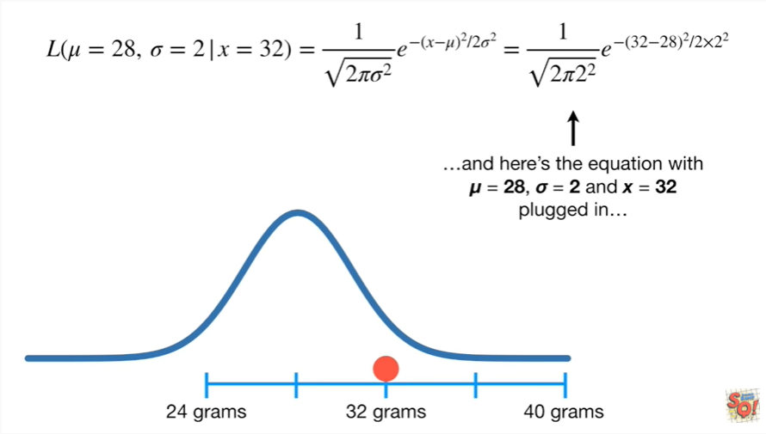

and here's the equation with mu equals 28 Sigma equals 2 and x equals 32 plugged in.

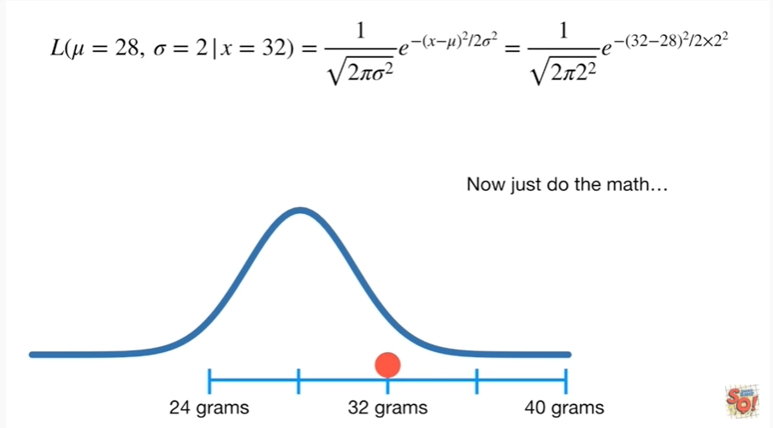

Now just do the math

plug and chug plug and chug

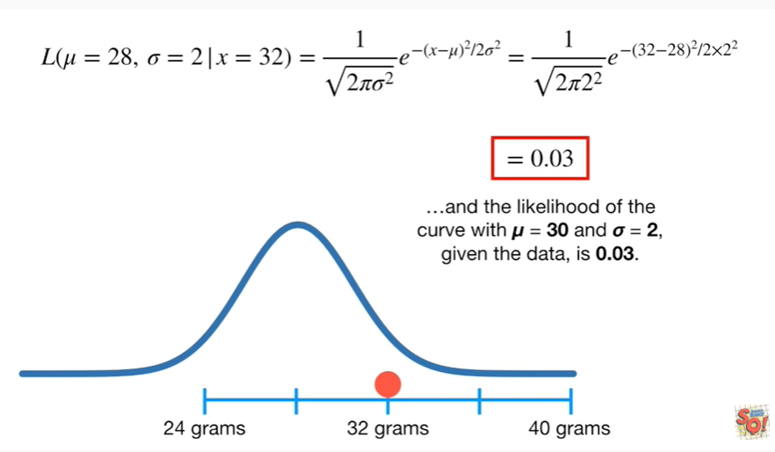

and the likelihood of the curve with mu equals 30 and Sigma equals 2 given the data, is 0.03.

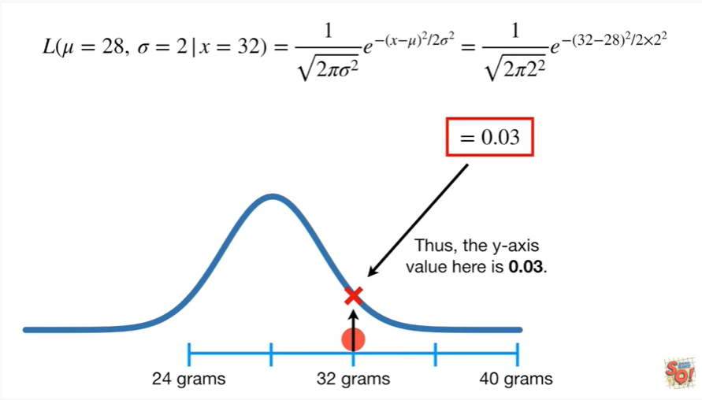

Thus, the y-axis value here is 0.03.

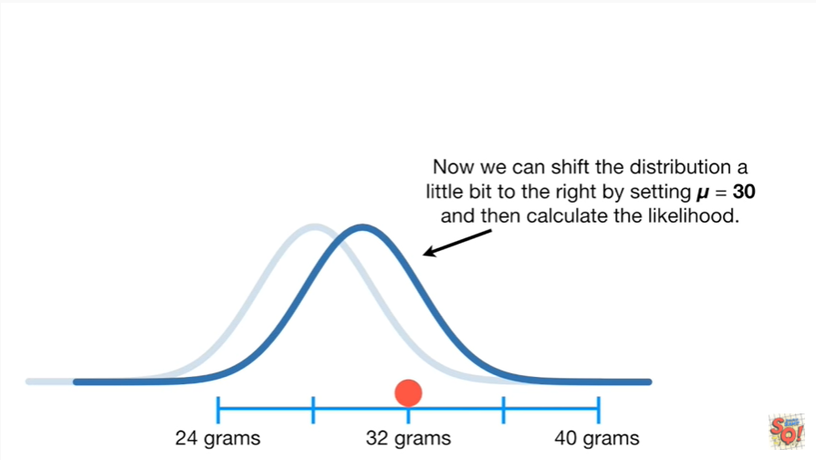

Now we can shift the distribution a little bit to the right by setting mu equals 30 and then calculate the likelihood.

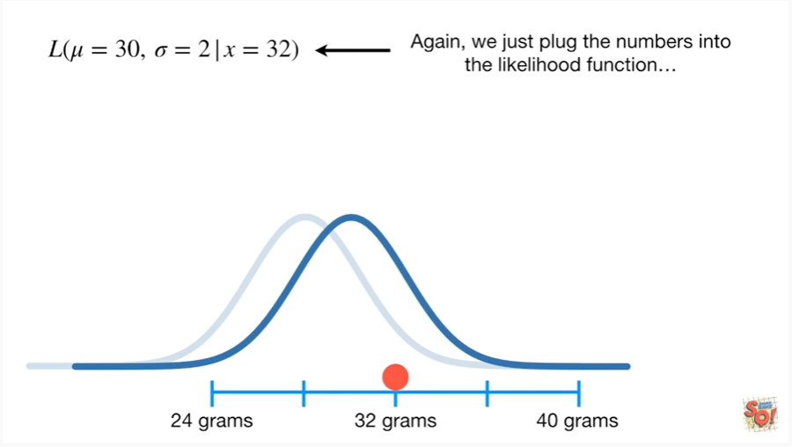

Again, we just plug the numbers into the likelihood function

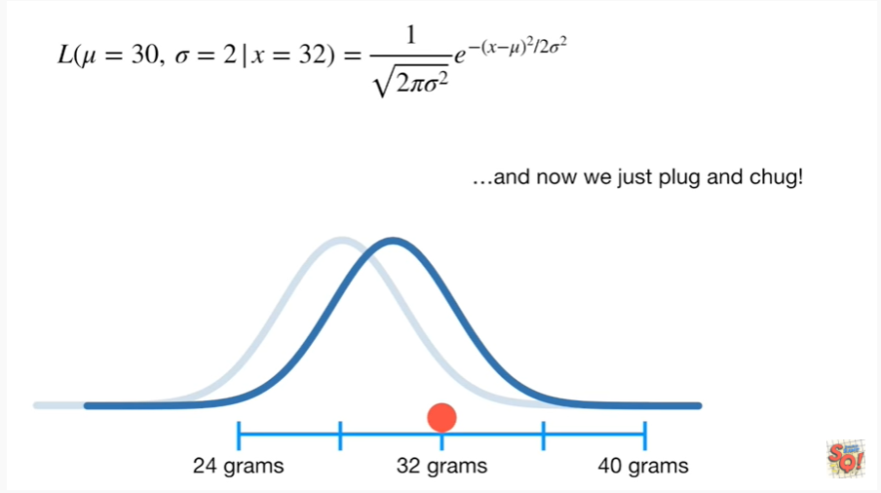

and now we just plug and chug !

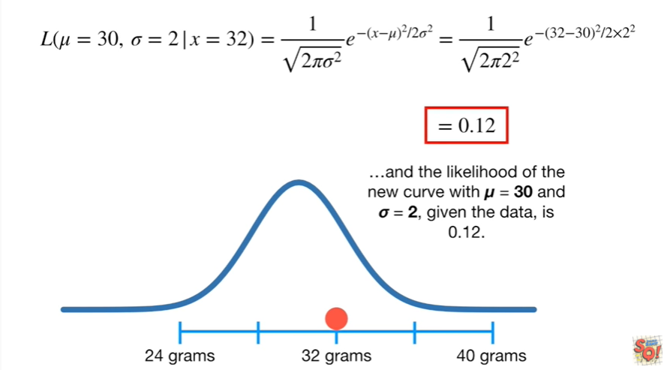

and the likelihood of the new curve with mu equals 30, and Sigma equals 2, given the data, is 0.12.

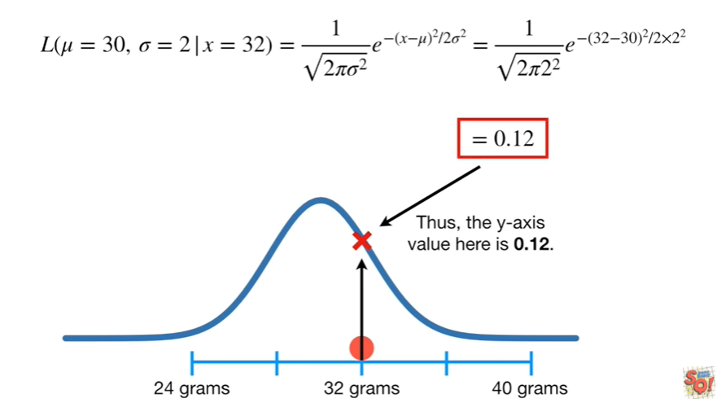

Thus, the y-axis value here is 0.12.

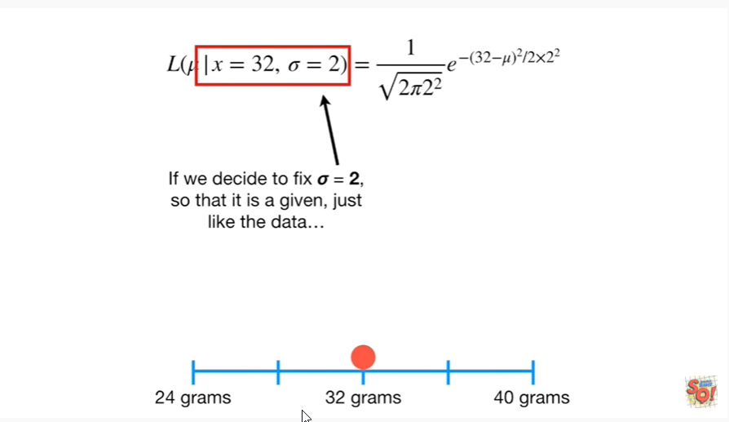

If we decide to fix Sigma equals 2, so that it is a given, just like the data

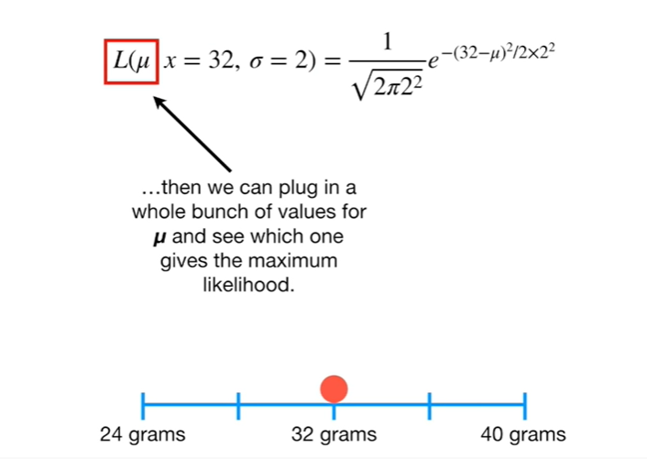

then we can plug in a whole bunch of values for mu and see which one gives the maximum likelihood.

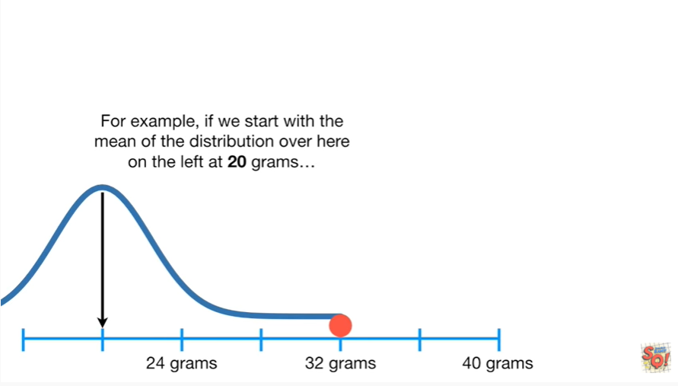

For example, if we start with the mean of the distribution over here on the left at 20 grams

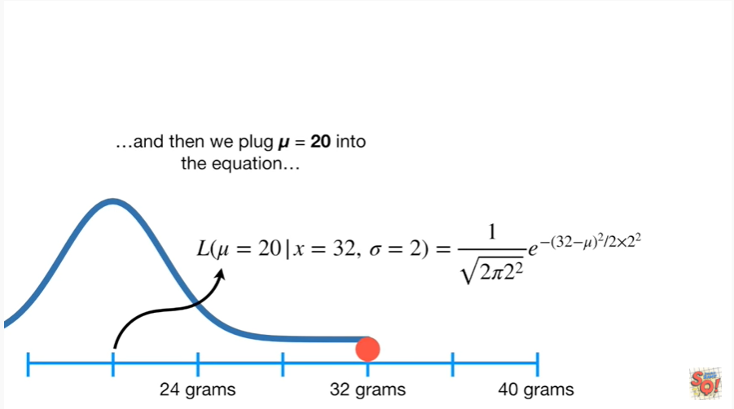

then we plug mu equals 20 into the equation

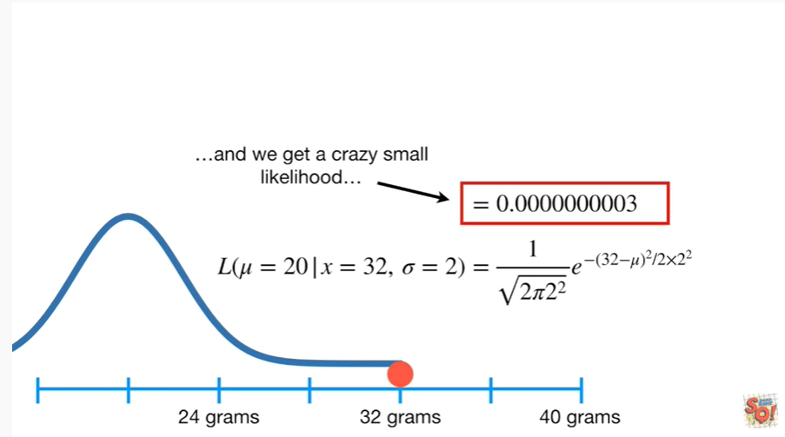

and we get a crazy small likelihood

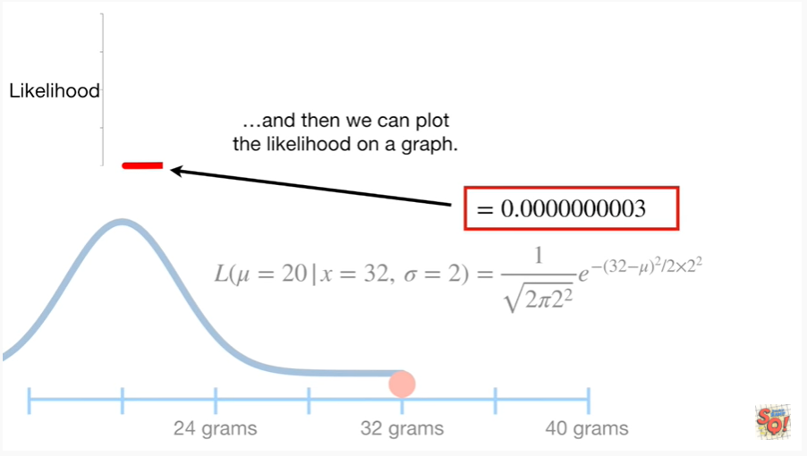

and then we can plot the likelihood on a graph.

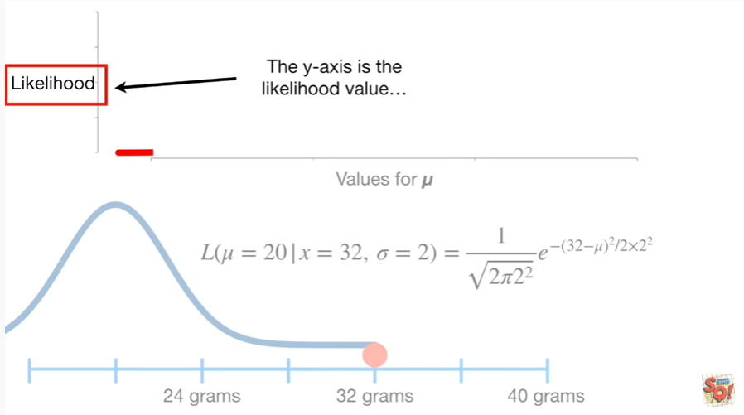

The y-axis is the likelihood value

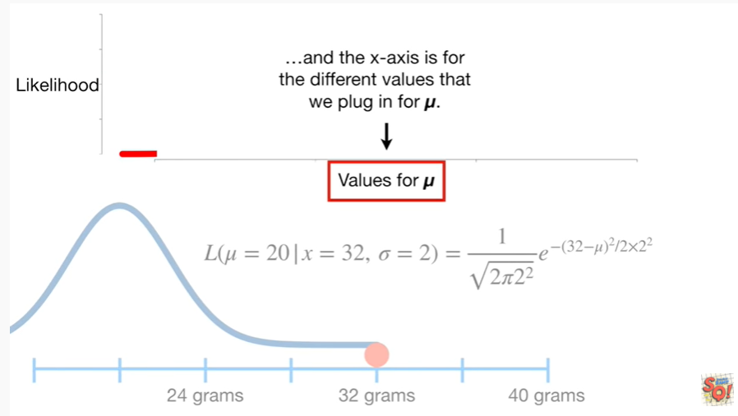

and the x-axis is for the different values that we plug in for MU

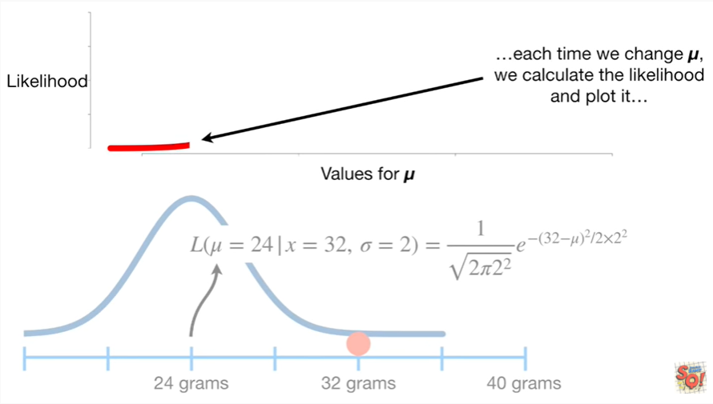

each time we change mu, we calculate the likelihood and plot it.

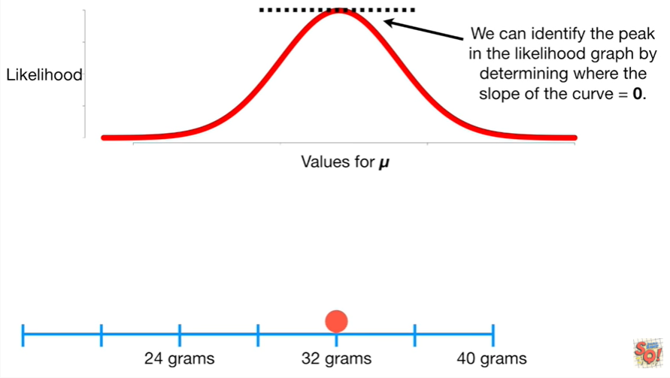

We can identify the peak in the likelihood graph by determining where the slope of the curve equals zero.

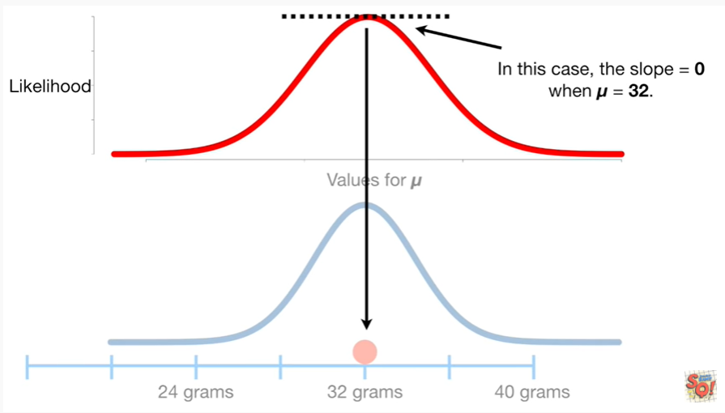

In this case, the slope equals zero when mu equals 32.

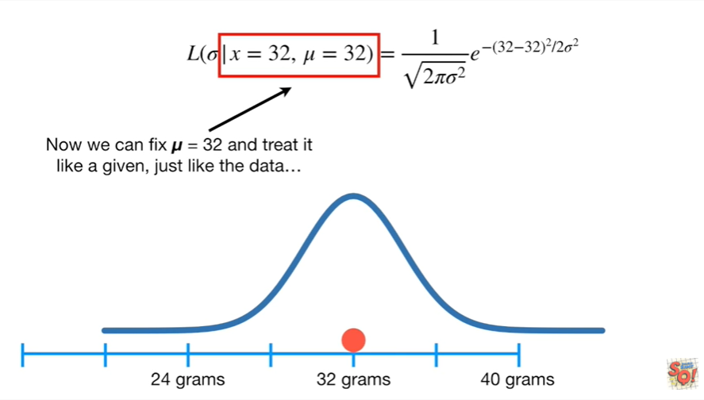

Now we can fix mu equals 32 and treat it like a given, just like the data

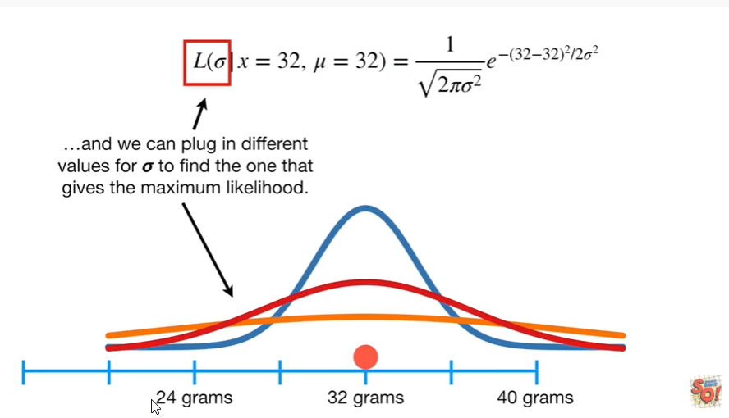

and we can plug in different values for Sigma to find the one that gets the maximum likelihood.

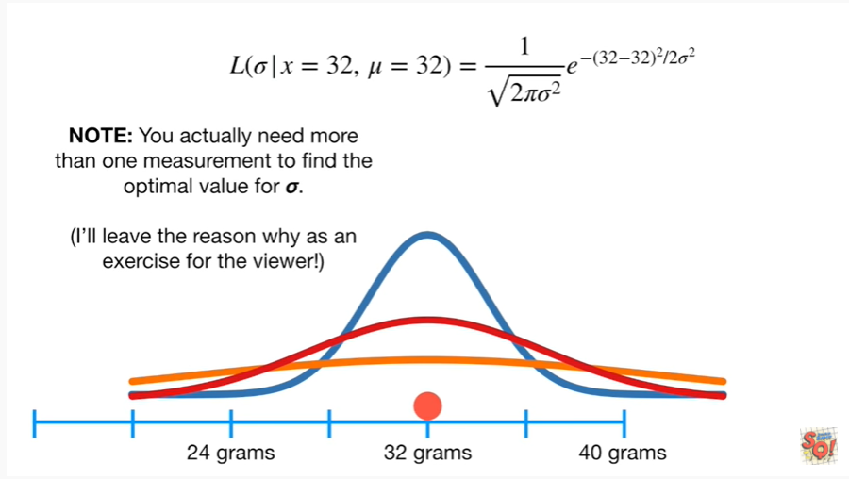

Note : you actually need more than one measurement to find the optimal value for Sigma.

I'll leave the reason why as an exercise for the viewer !

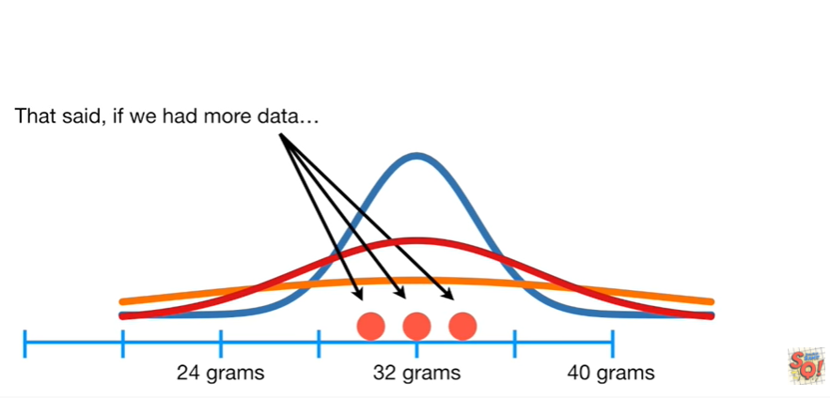

That said if we had more data

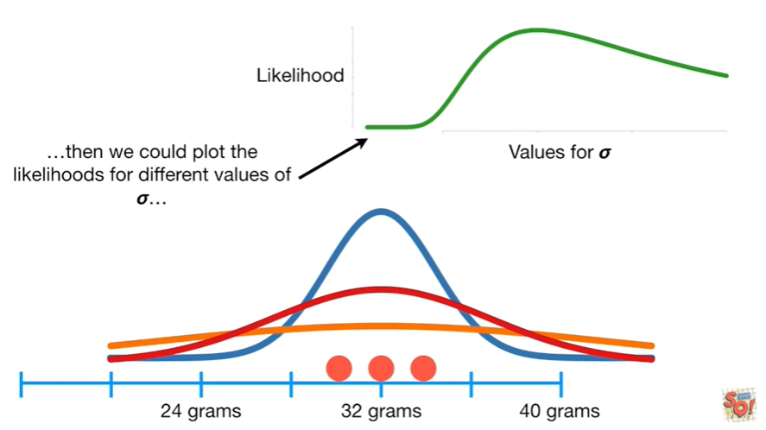

then we could plot the likelihoods for different values of Sigma

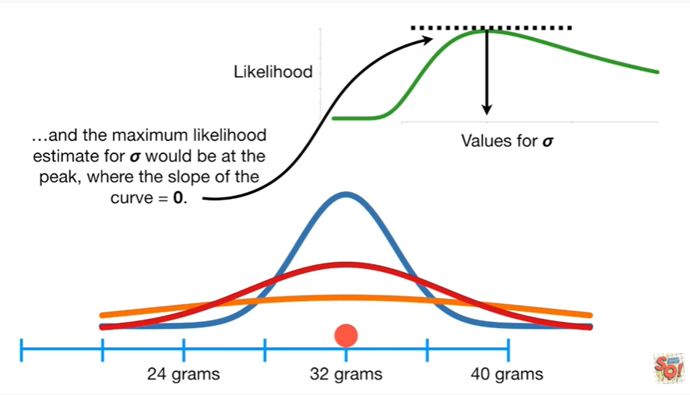

and the maximum likelihood estimate for Sigma would be at the peak with a slope of the curve equals zero.

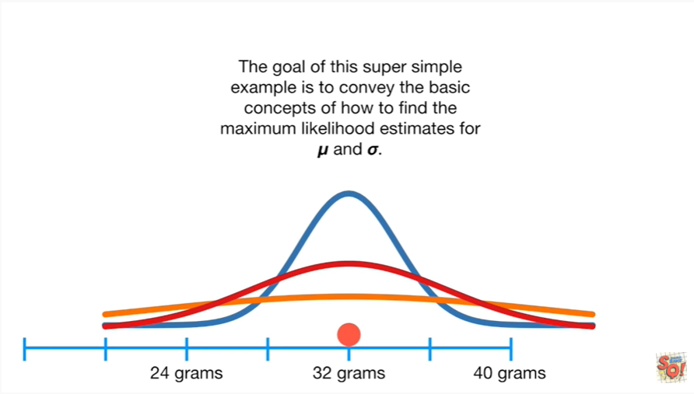

The goal of this super simple example is to convey the basic concepts of how to find the maximum likelihood estimates for MU and Sigma.

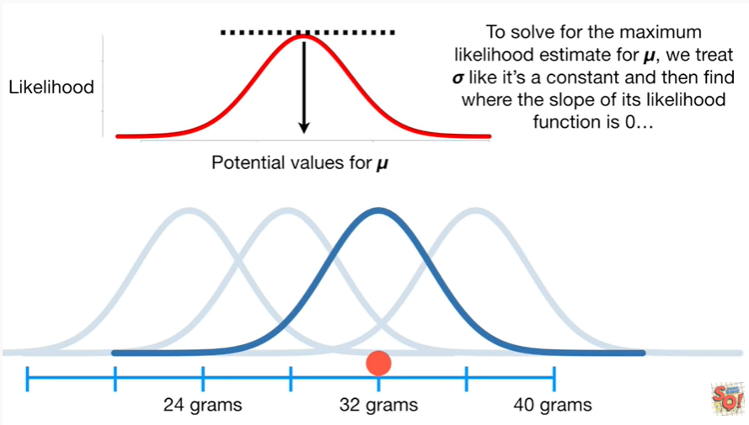

To solve for the maximum likelihood estimate for MU, we treat Sigma like it's a constant and then find where the slope of its likelihood function is 0

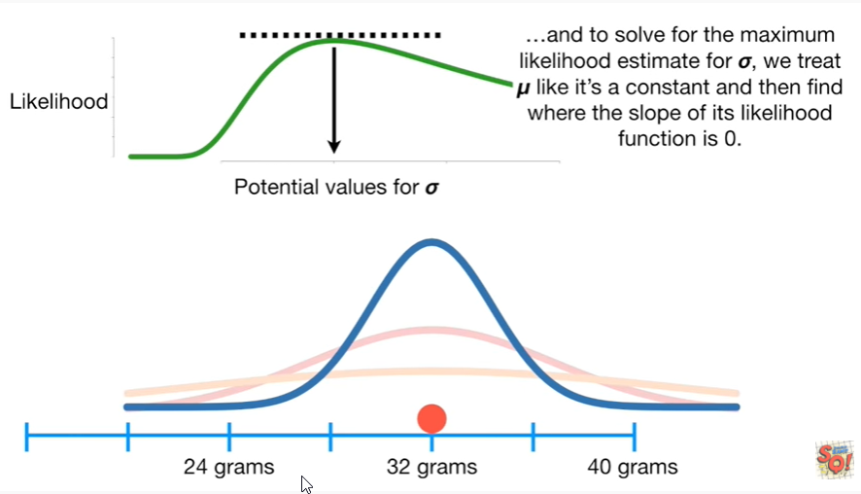

and to solve for the maximum likelihood estimate for Sigma we treat me like it's a constant and then find where the slope of its likelihood function is 0.

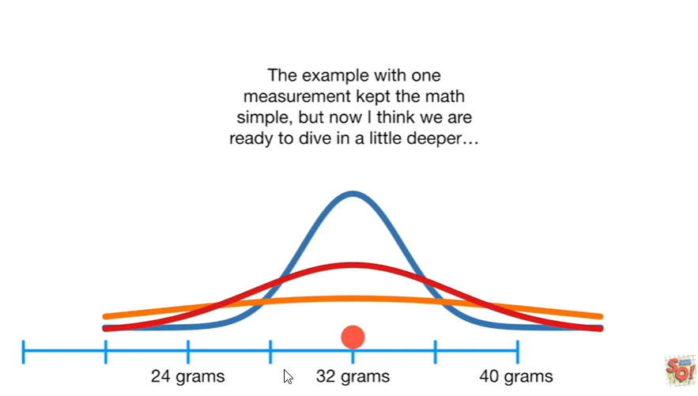

The example with one measurement kept the math simple, but now I think we're ready to dive in a little deeper

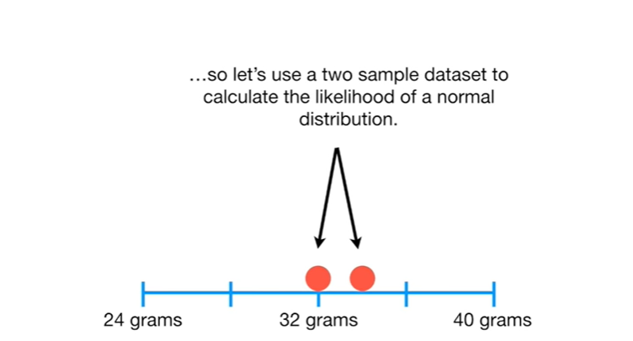

so let's use a two sample data set to calculate the likelihood of a normal distribution.

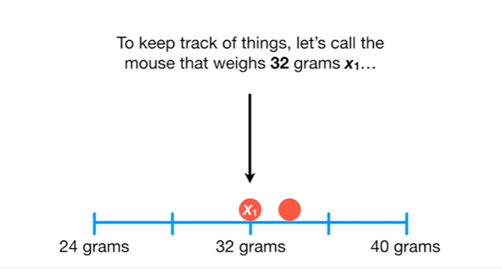

Crazy times !

To keep track of things, let's call the mouse that weighs 32 grams X sub 1.

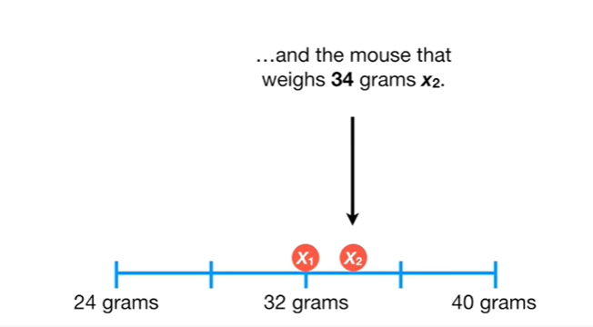

and the mouse that weighs 34 grams X sub 2.

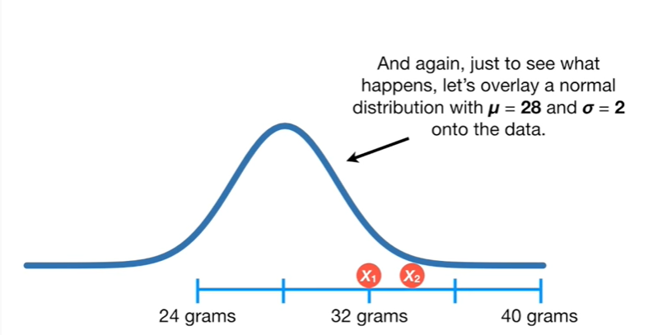

And again just to see what happens, let's overlay a normal distribution with mu equals 28 and Sigma equals 2 onto the data.

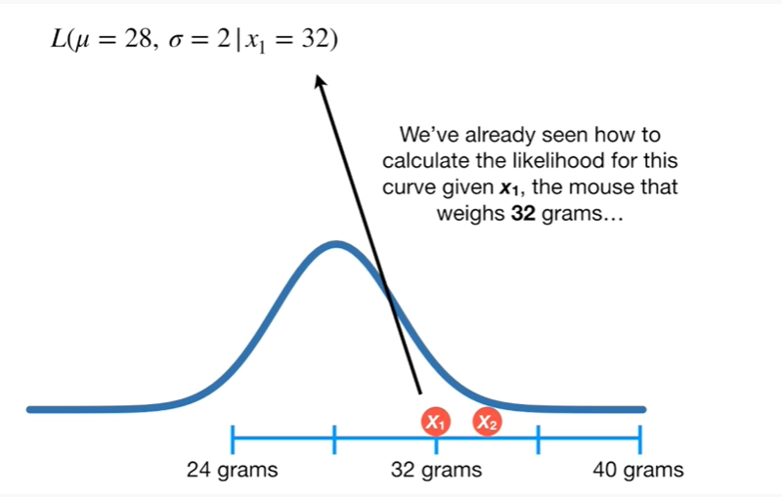

We've already seen how to calculate the likelihood for this curve given X sub 1, the mouse that weighs 32 grams

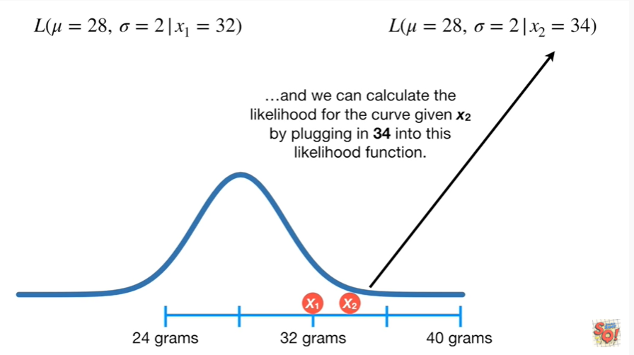

and we can calculate the likelihood for the curve given X sub 2 by plugging in 34 into this likelihood function

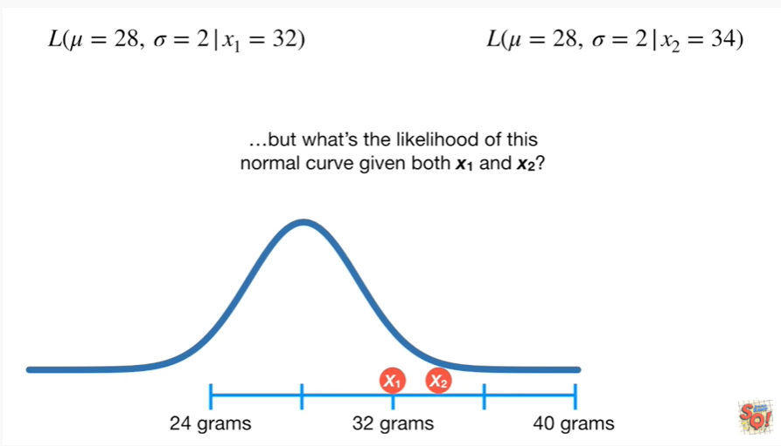

but what's the likelihood of this normal curve given both X sub 1 and X sub 2 ?

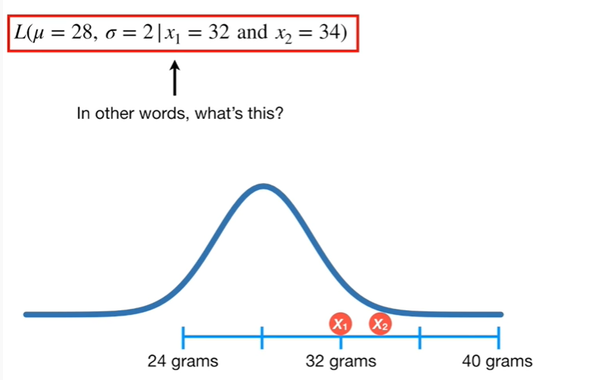

In other words, what's this ?

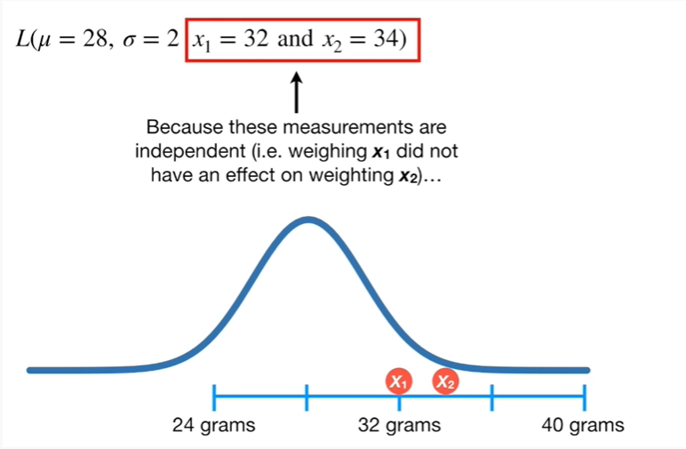

Because these measurements are independent (ie weighing X sub 1 did not have an effect on weighing X sub 2)

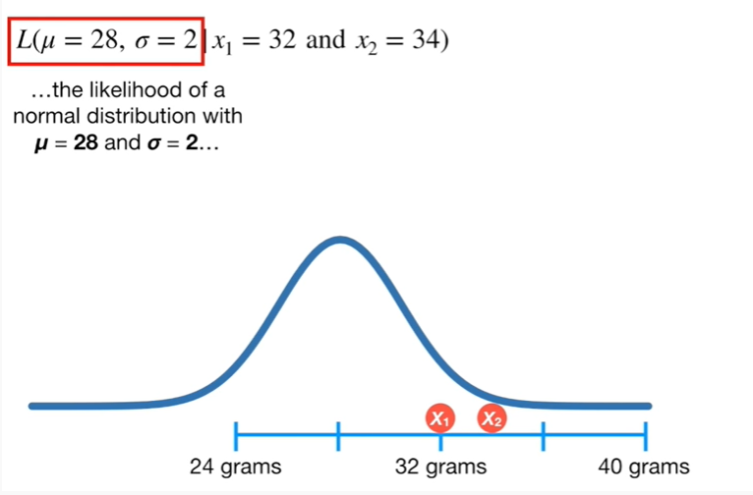

the likelihood of a normal distribution with mu equals 28 and Sigma equals 2

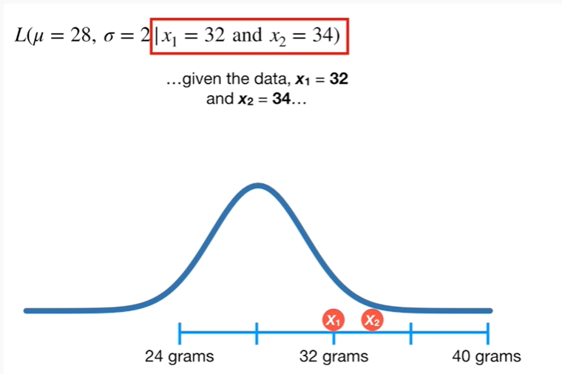

given the data X sub 1 equals 32 and X sub 2 equals 34

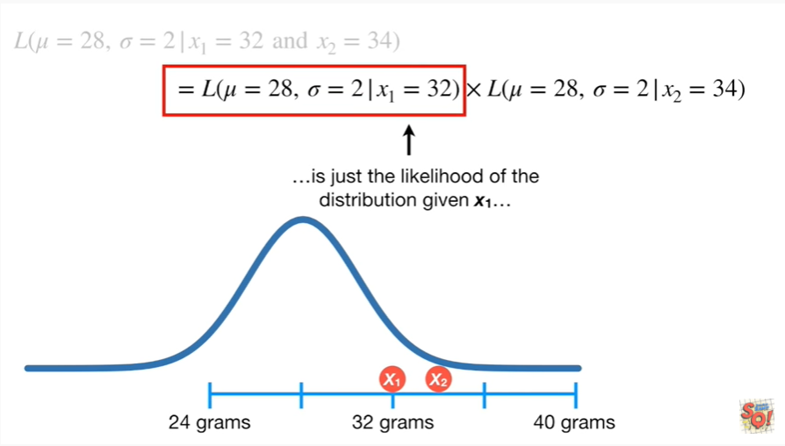

is just the likelihood of the distribution given X sub 1

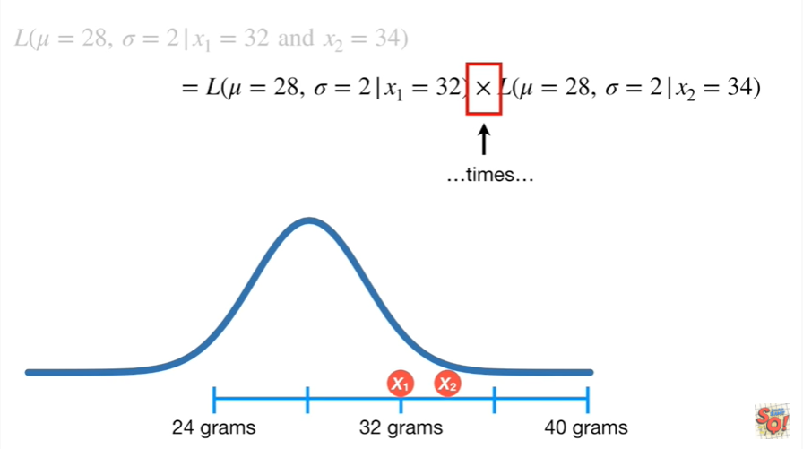

times

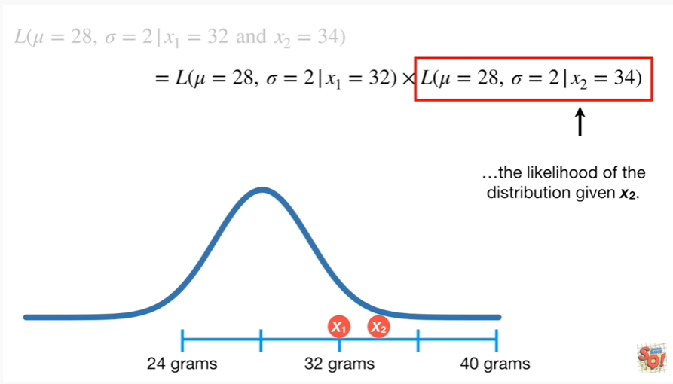

the likelihood of the distribution given X sub 2.

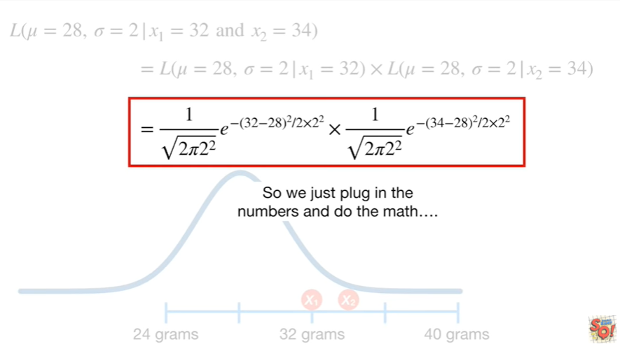

So we just plug in the numbers and do the math

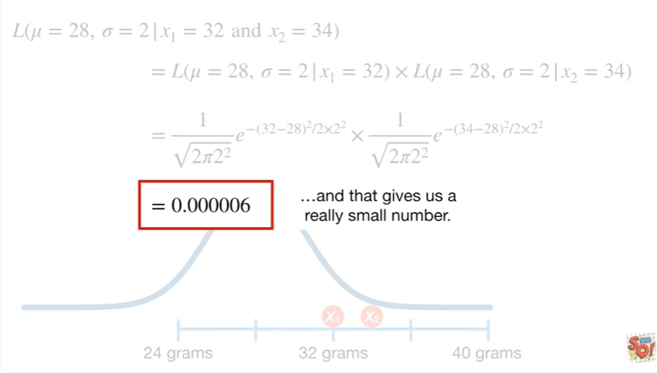

and that gives us a really small number.

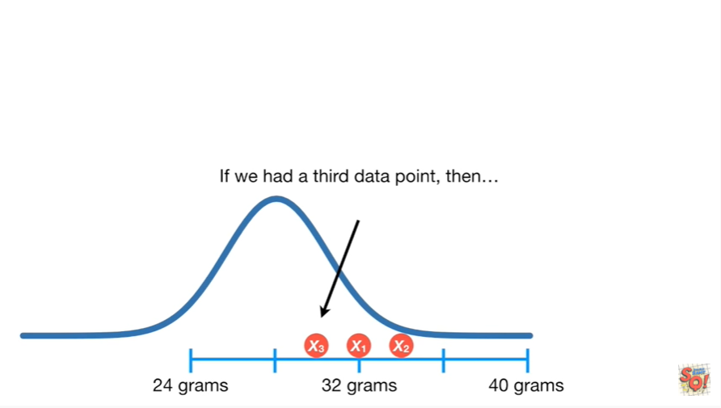

If we had a third data point, then

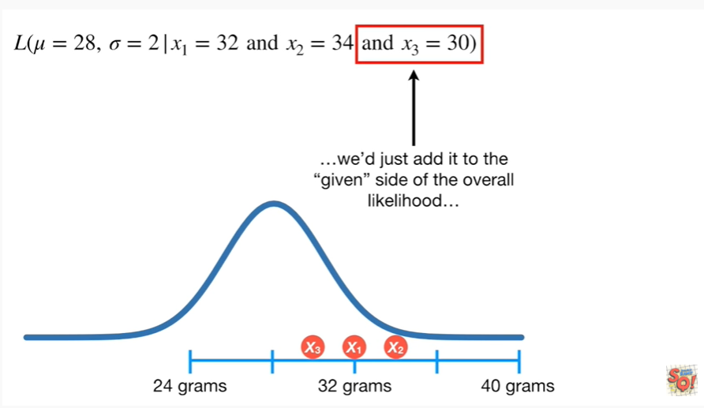

we just add it to the given side of the overall likelihood

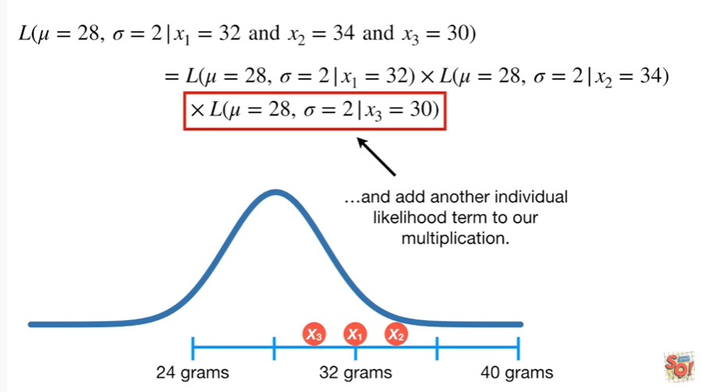

and add another individual likelihood term to our multiplication.

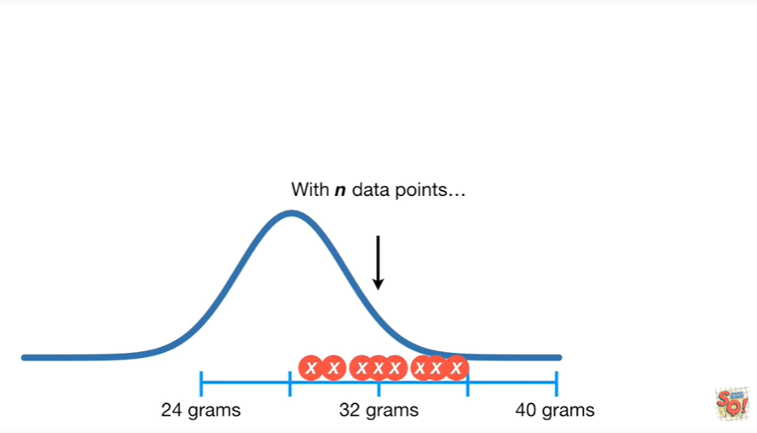

With n data points

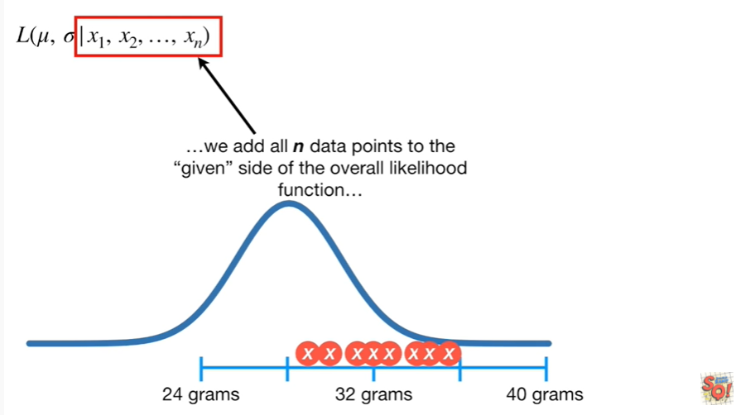

we add all n data points to the given side of the overall likelihood function

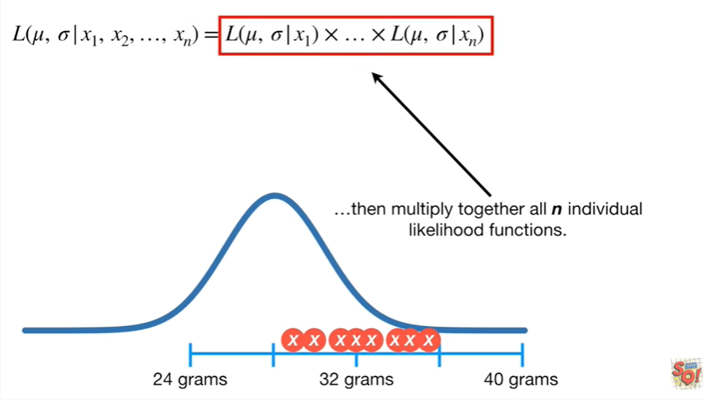

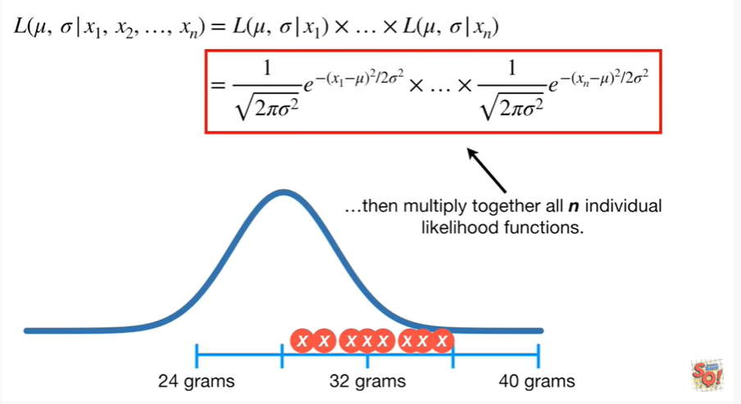

then multiplied together all in individual likelihood functions.

BAM !!!

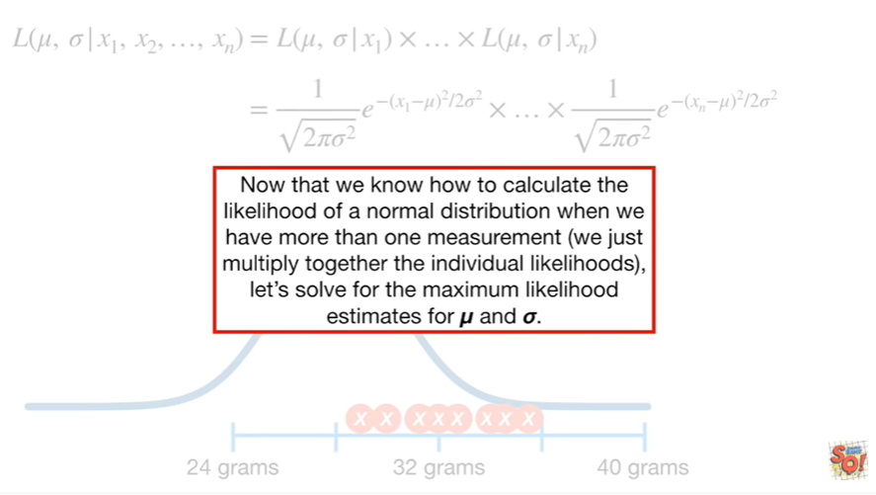

Now that we know how to calculate the likelihood of a normal distribution and when we have more than one measurement we just multiply together the individual likelihoods let's solve for the maximum likelihood estimates for MU and Sigma.

Brace yourself for a lot of math but don't freak out !

We'll go through it one step at a time.

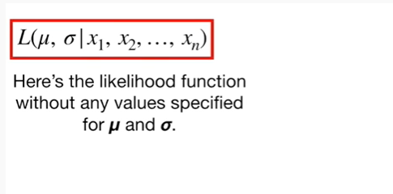

Here's the likelihood function without any value specified for MU and Sigma.

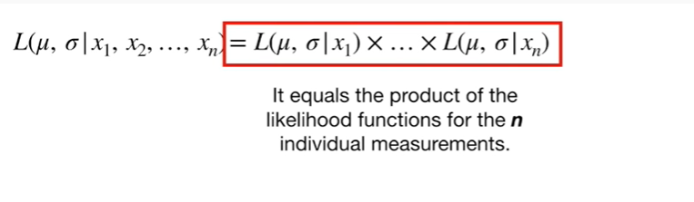

It equals the product of the likelihood functions for the N individual measurements

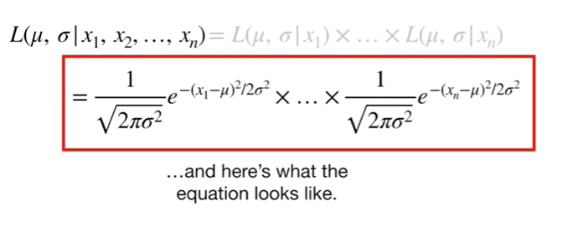

and here's what the equation looks like.

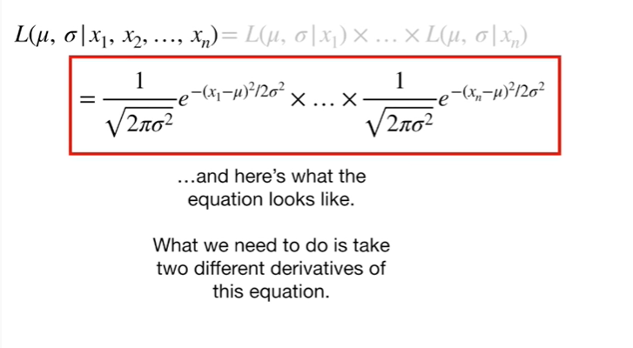

What we need to do is take two different derivatives of this equation.

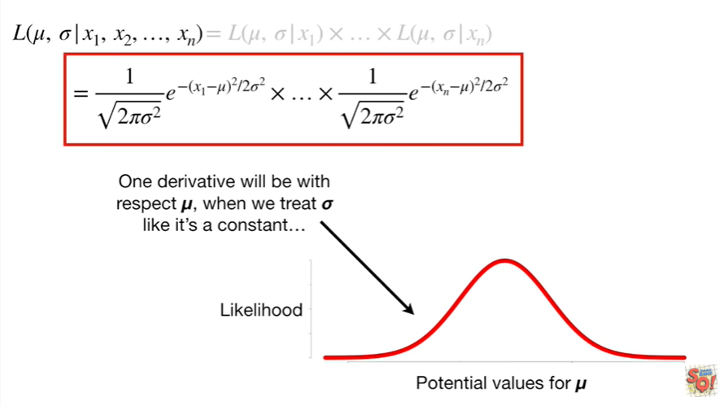

One derivative will be with respect to MU, when we treat Sigma like it's a constant

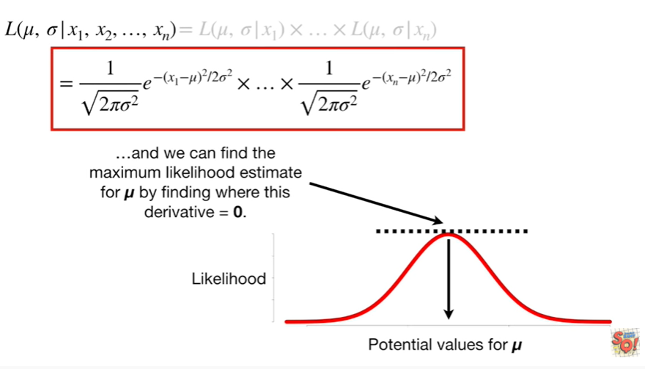

and we can find the maximum likelihood estimate for MU by finding where this derivative equals zero.

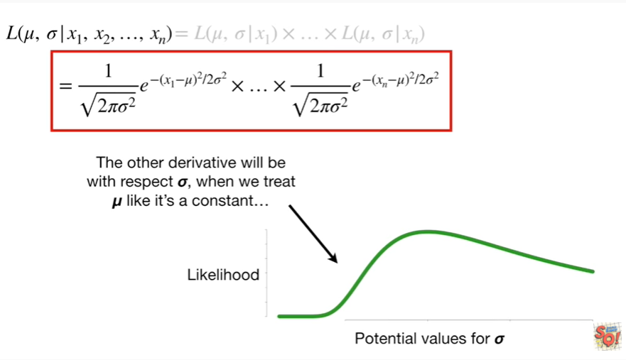

The other derivative will be with respect to Sigma, when we treat mu like it's a constant

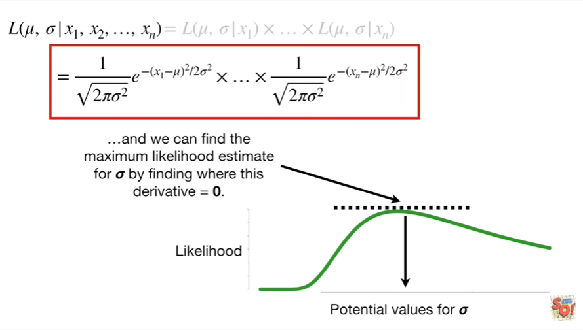

and we can find the maximum likelihood estimate for Sigma by finding where this derivative equals zero.

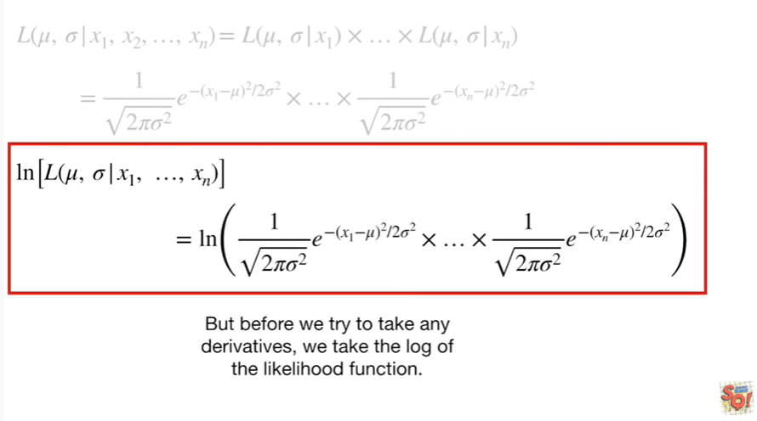

But before we try to take any derivatives let's take the log of the likelihood function.

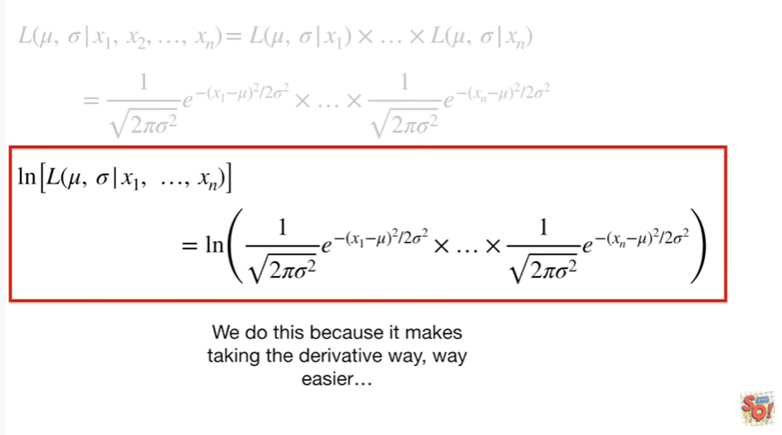

We do this because it makes taking the derivative way, way easier

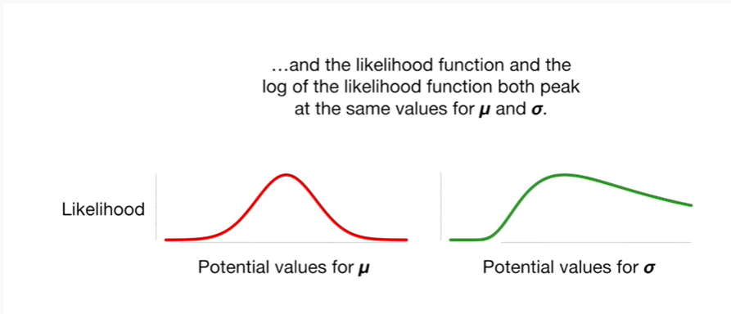

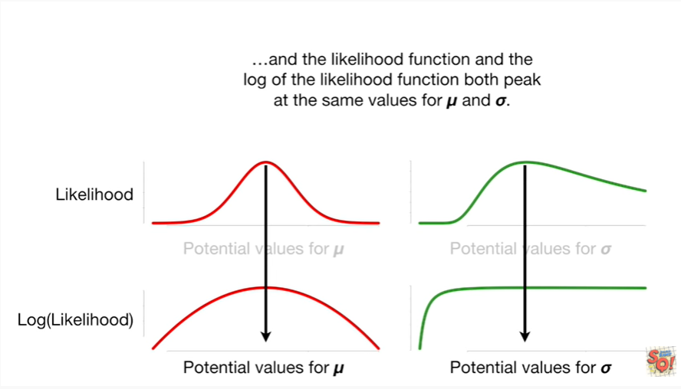

and the likelihood function and the log of the likelihood function both peak at the same values for MU and Sigma.

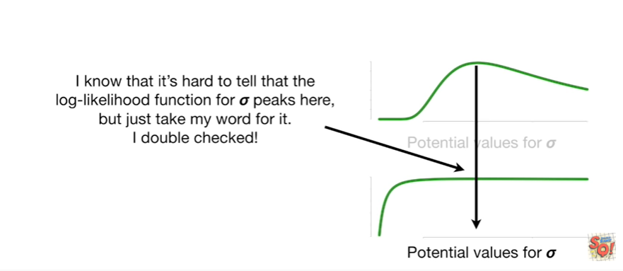

I know it's hard to tell that the log likelihood function for Sigma peeks, here but just take my word for it.

I double-checked !

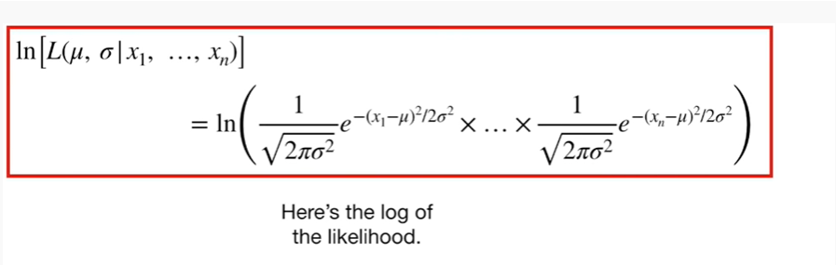

Here's the log of the likelihood.

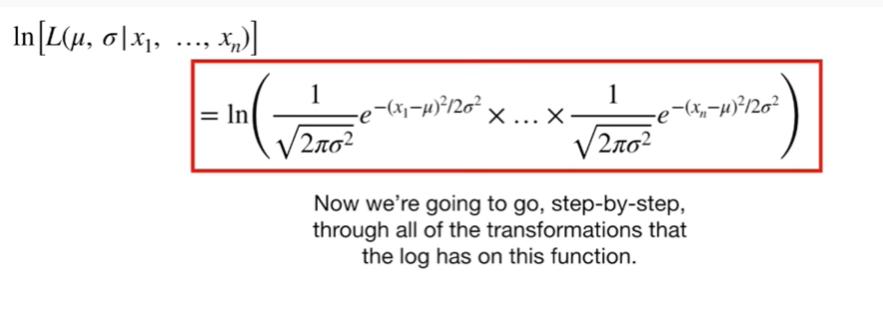

Now we're going to go step by step, through all of the transformations that the log has on this function.

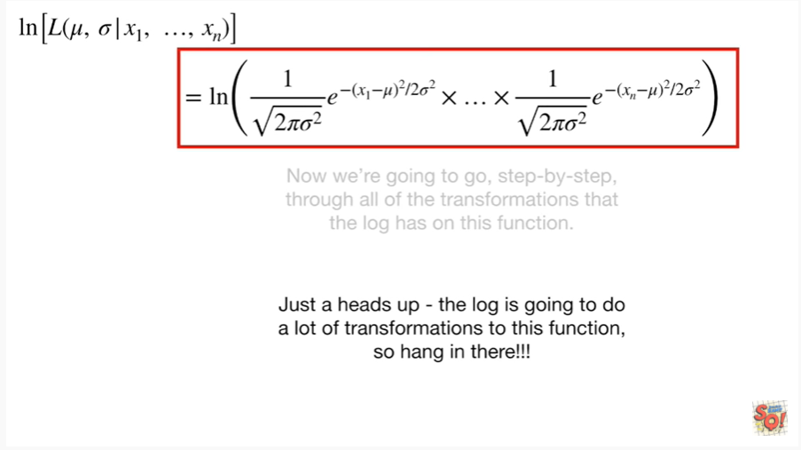

Just a heads up - the log is going to do a lot of transformations to this function so hang in there !!!

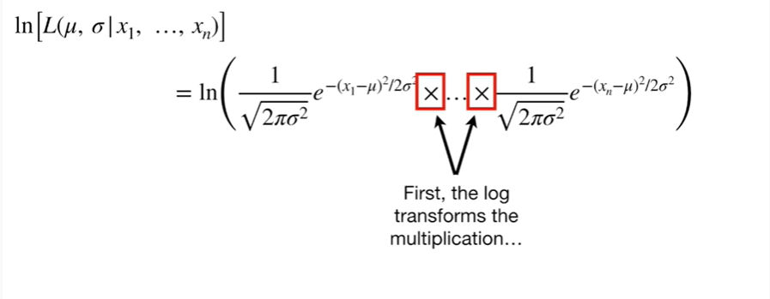

First, the log transforms the multiplication

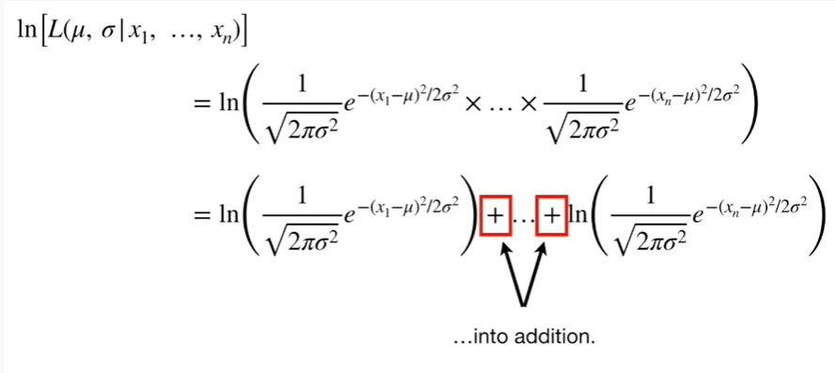

into addition.

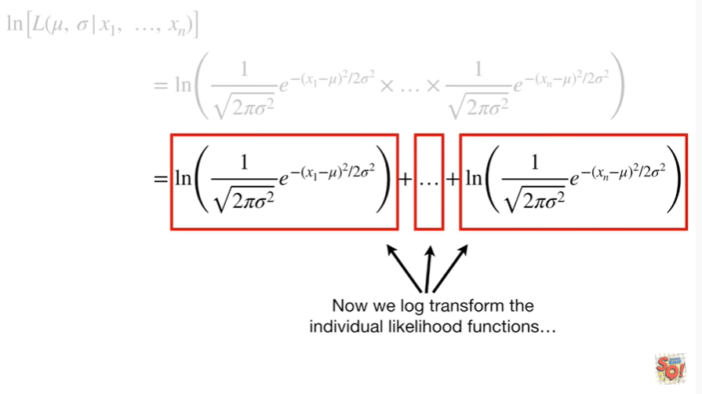

Now we log transform the individual likelihood function.

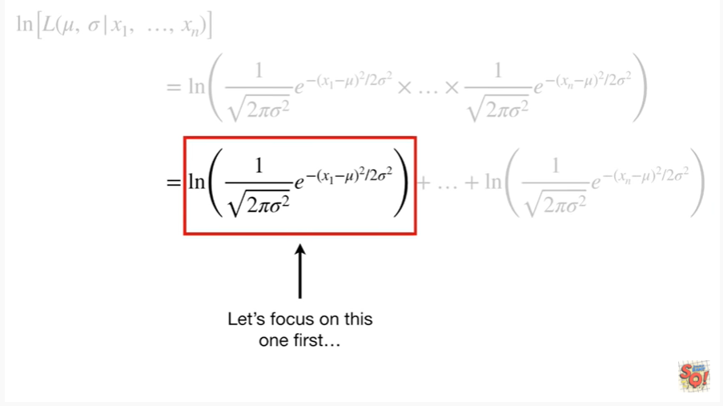

Let's focus on this one first.

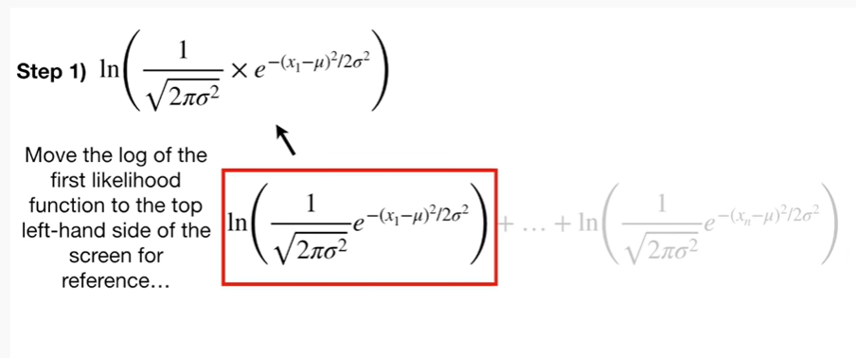

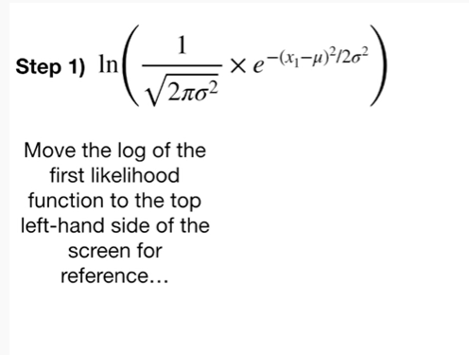

Step 1 : move the log of the first likelihood function to the top left-hand side of the screen for reference.

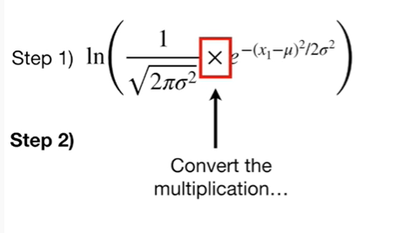

Step 2 : convert the multiplication

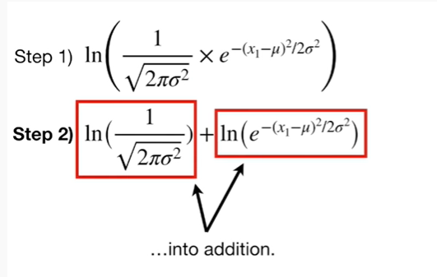

into addition.

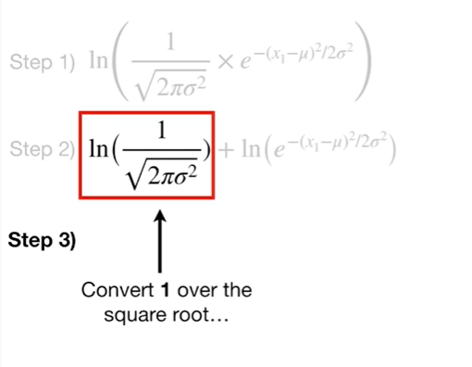

Step 3 : convert 1 over the square root

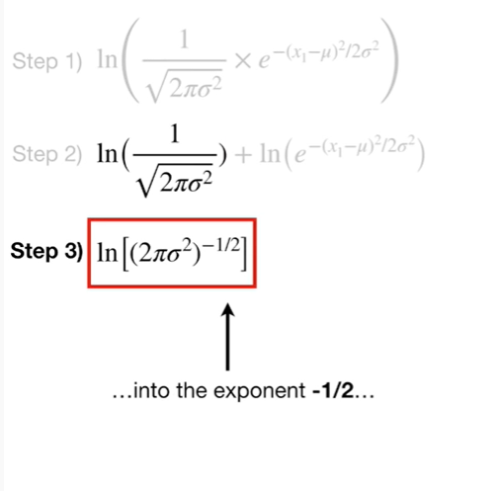

into the exponent negative 1/2

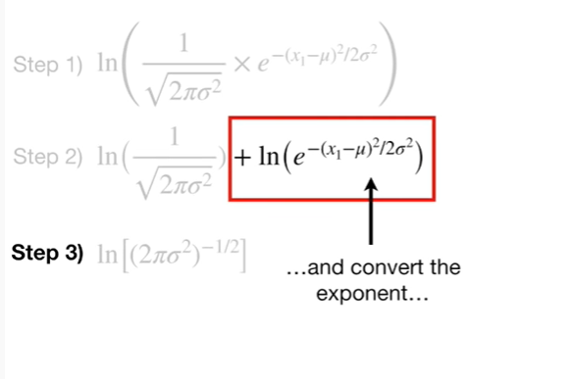

and convert the exponent

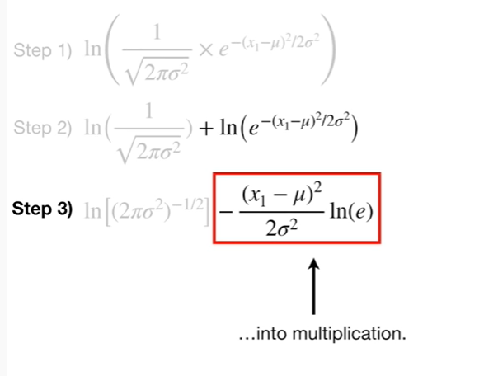

into multiplication.

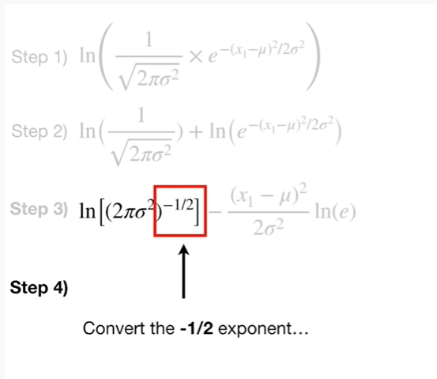

Step 4 : convert the negative 1/2 exponent

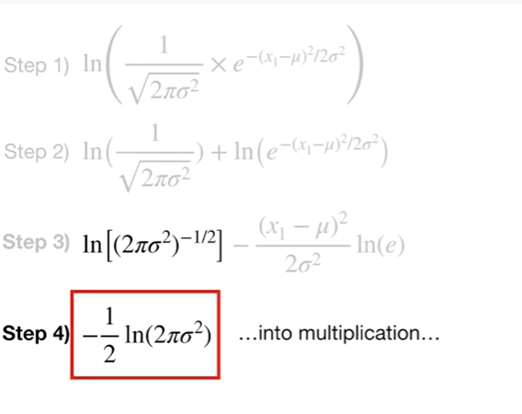

into multiplication

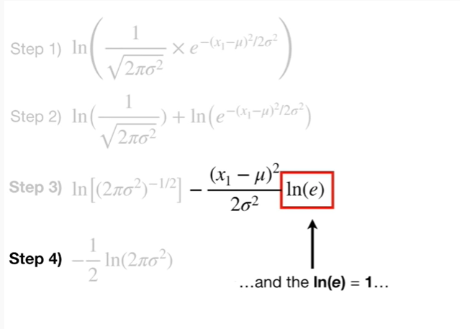

and the log of e equals 1

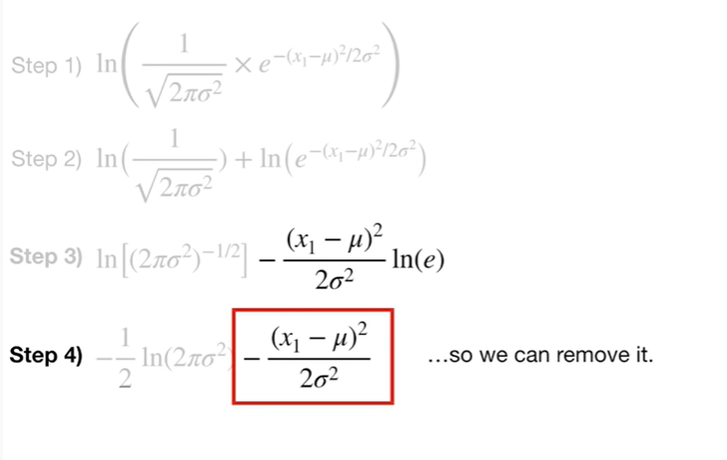

so we can remove it.

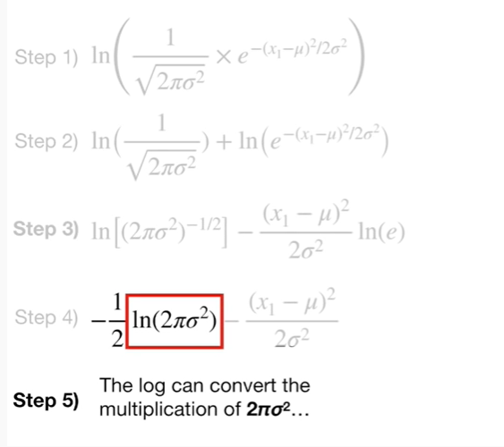

Step five : the log can convert the multiplication of two times pi times Sigma squared

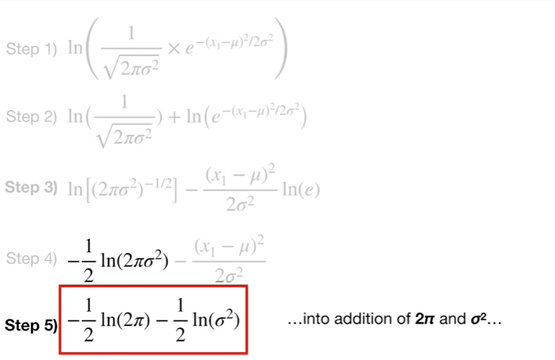

into addition of two times pi and Sigma squared

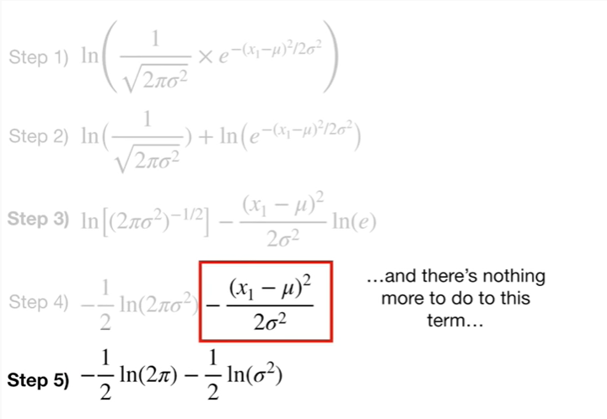

and there's nothing more to do to this term

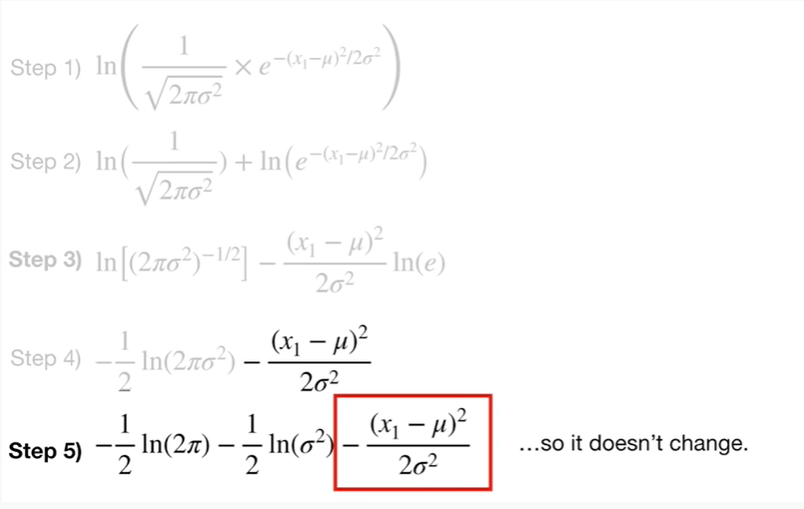

so it doesn't change.

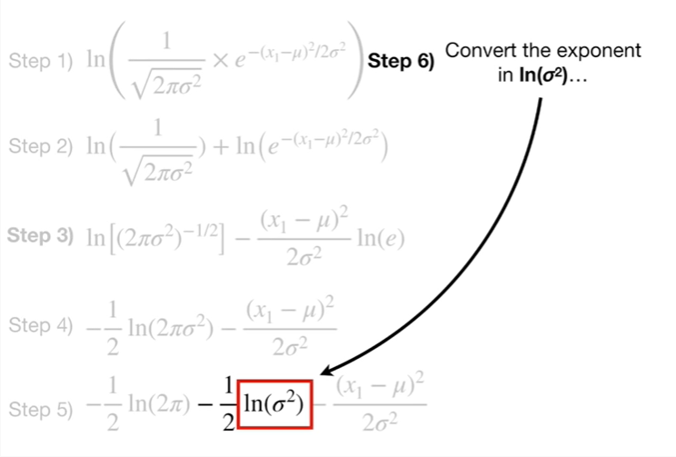

Step 6 : convert the exponent in the log of Sigma squared

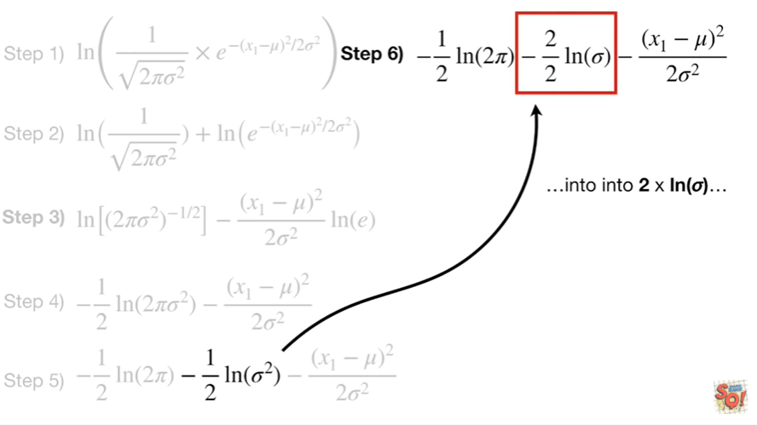

into 2 times the log of Sigma.

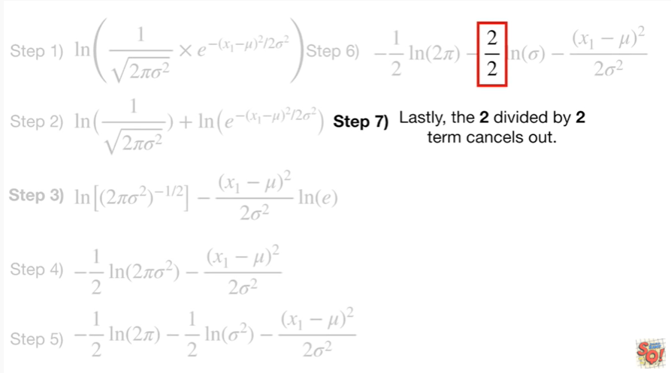

Step 7 : lastly the 2/2 term cancels out.

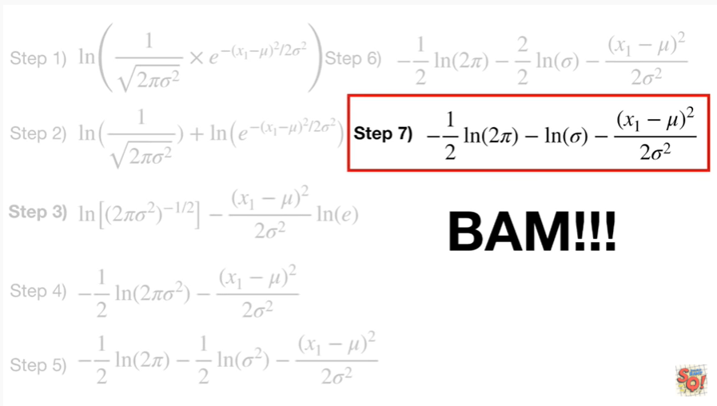

BAM !!!

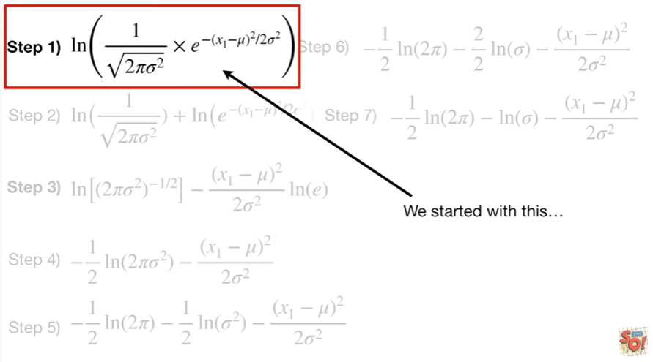

We started with this

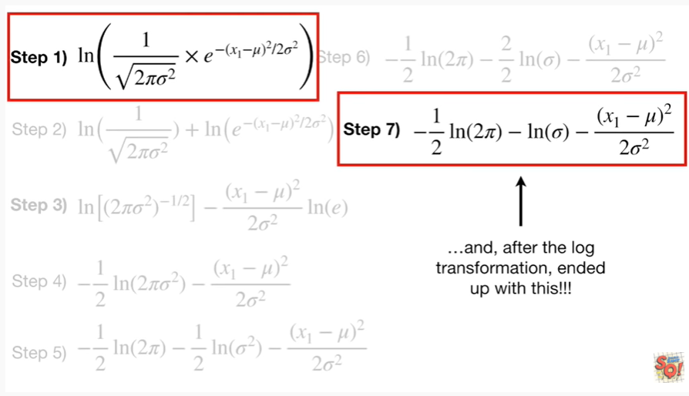

and after the log transformation, ended up with this !!!

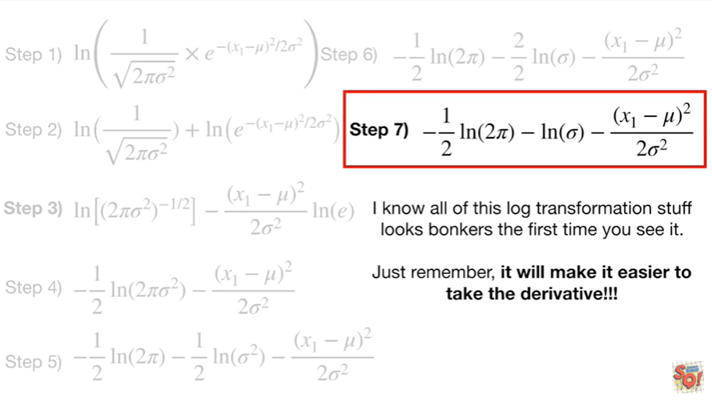

I know all of this log transformation stuff looks bonkers the first time you see it.

Just remember it will make it easier to take the derivative !!!

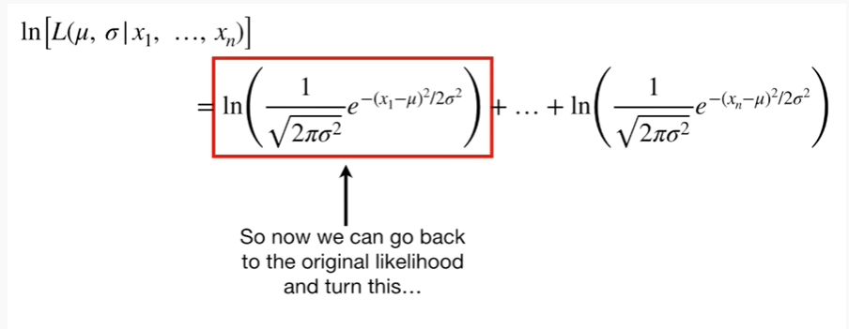

So now we can go back to the original likelihood and turn this

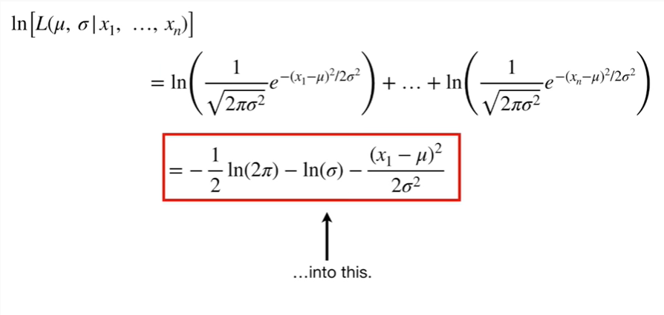

into this.

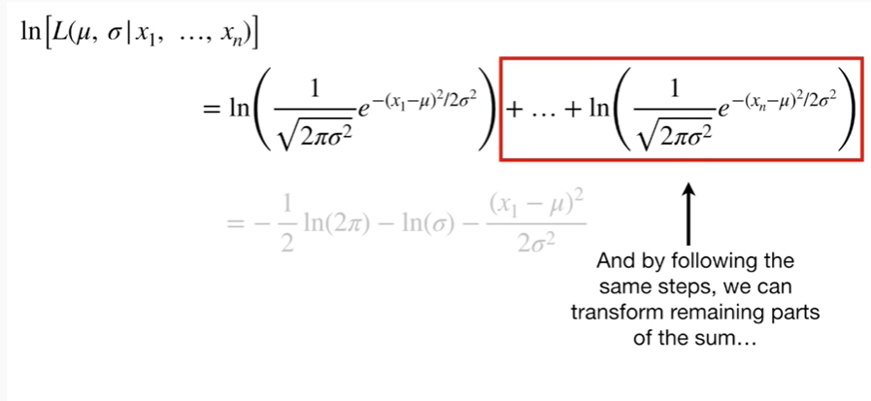

And by following the same steps, we can transform the remaining parts of the sum

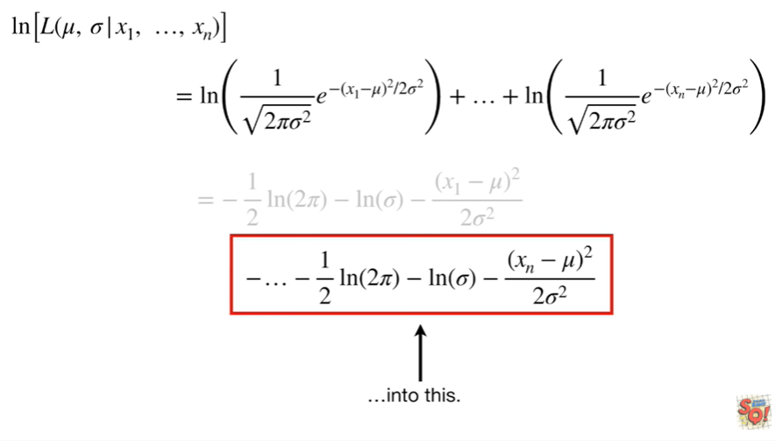into this.

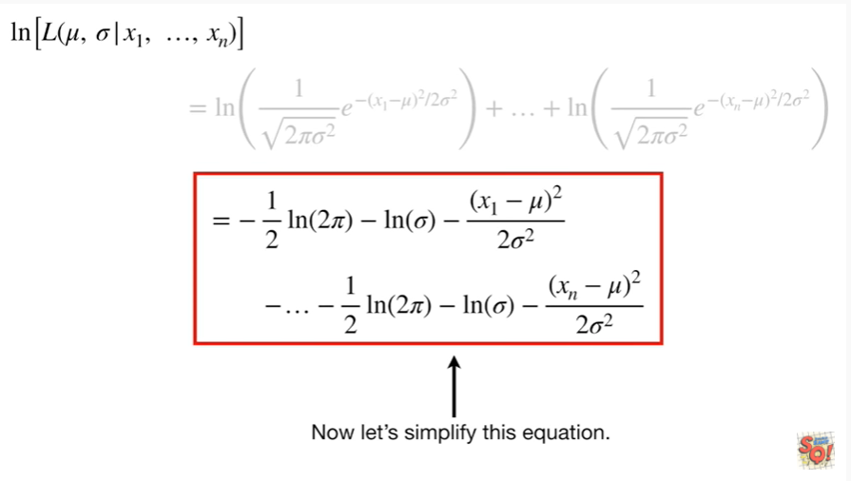

Now let's simplify this equation.

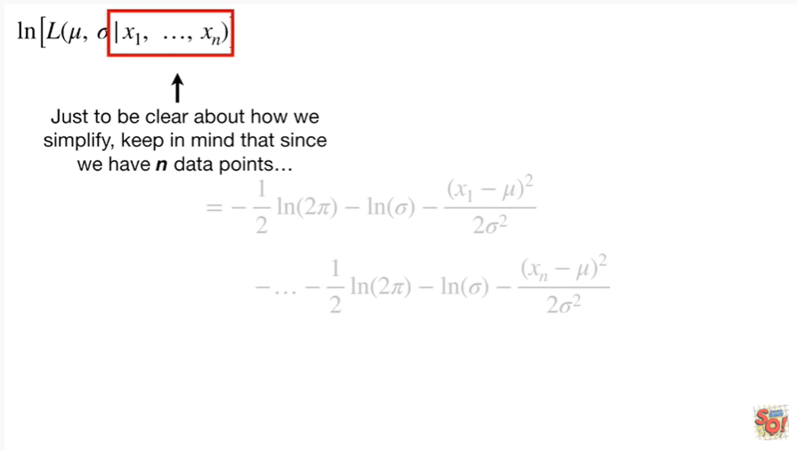

Just to be clear about how we simplify keep in mind that since we have n data points

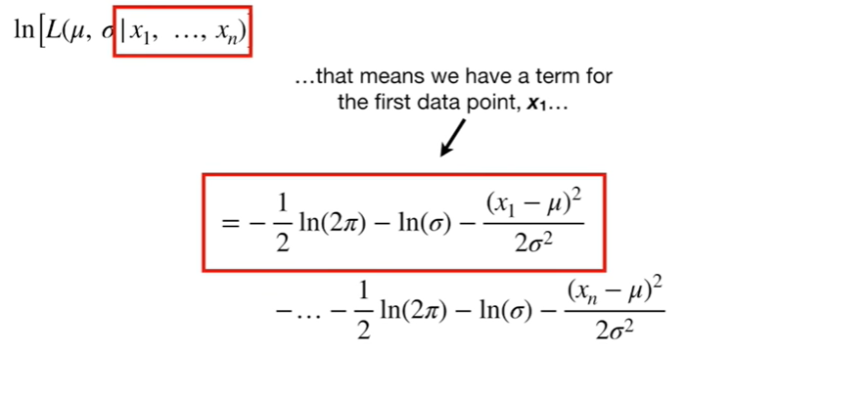

that means we have a term for the first data point X sub 1

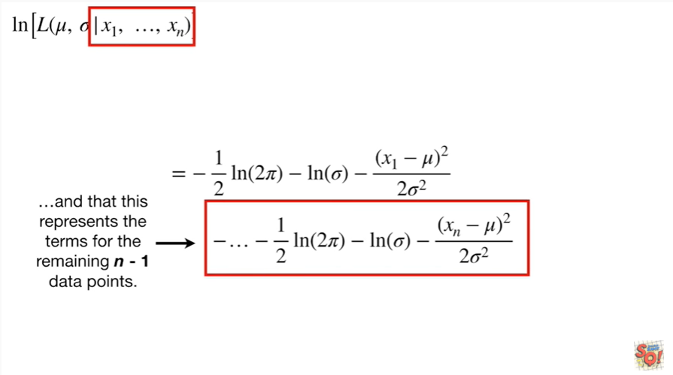

and that this represents the terms for the remaining n minus 1 data points.

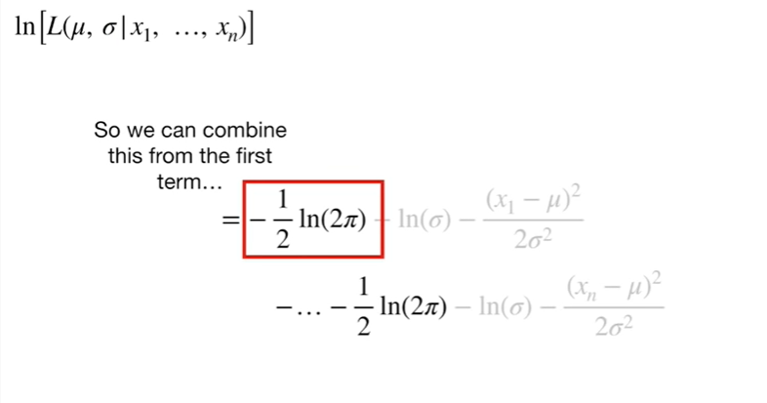

So we can combine this from the first term

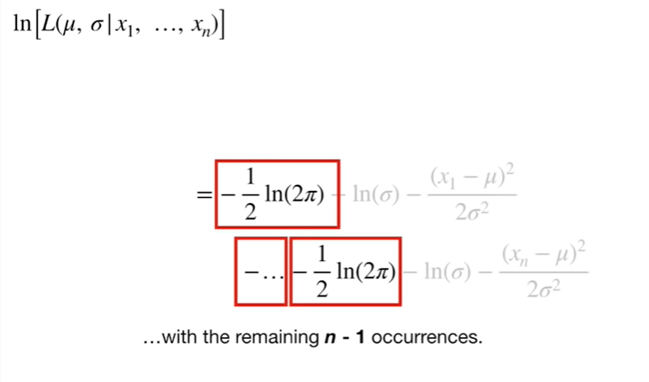

with the remaining n minus 1 occurrences

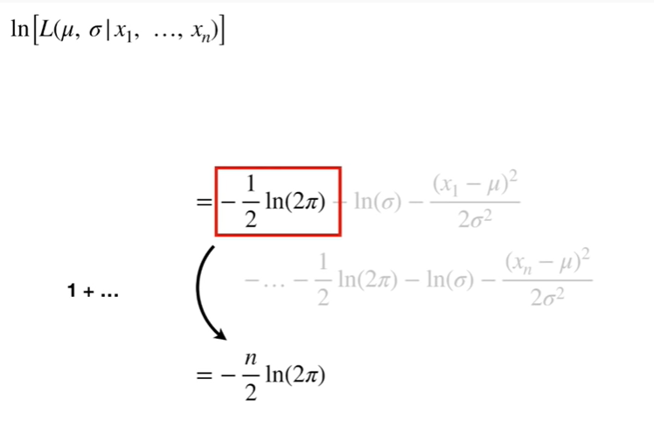

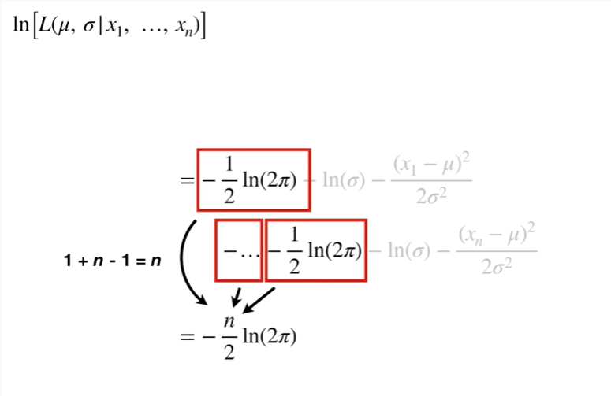

1 plus n minus 1 equals n.

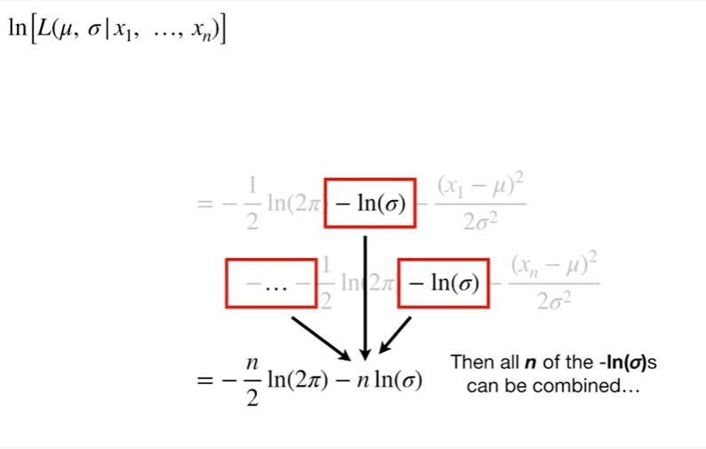

Then all n of the negative log of sigma's can be combined.

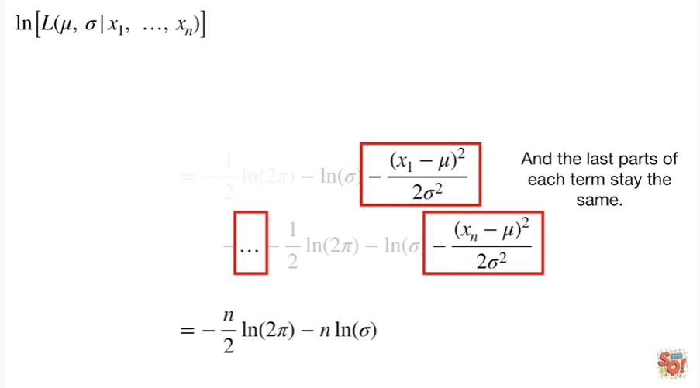

And the last parts of each term stay the same.

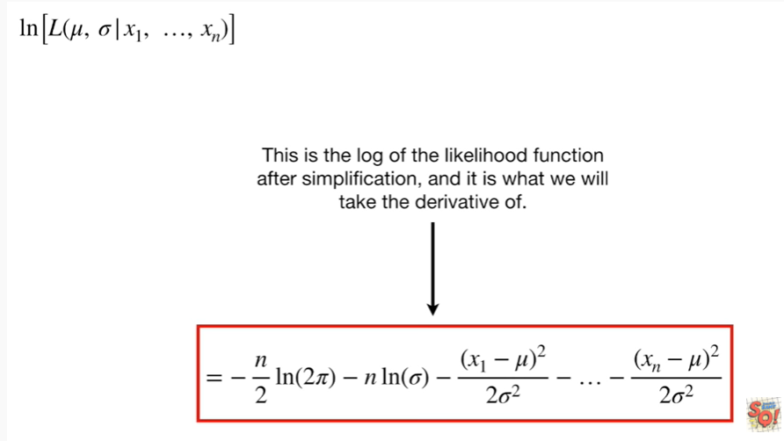

This is the log of the likelihood function after simplification, and it is what we will take the derivative of.

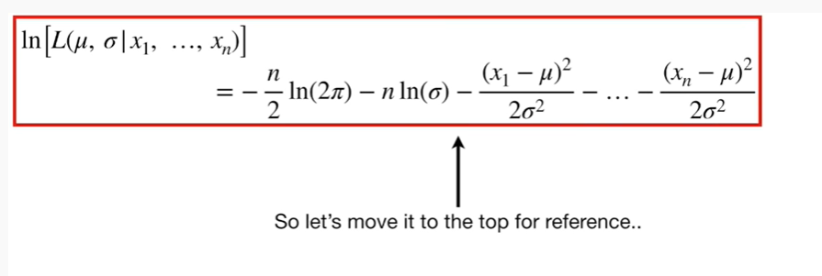

So let's move it to the top for reference.

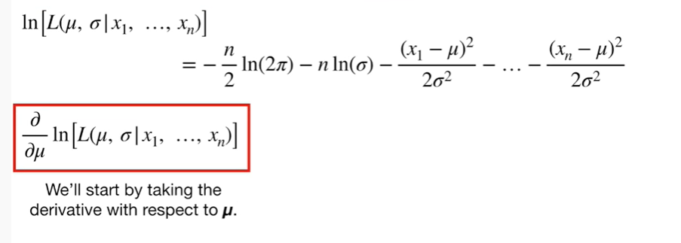

We'll start by taking the derivative with respect to MU.

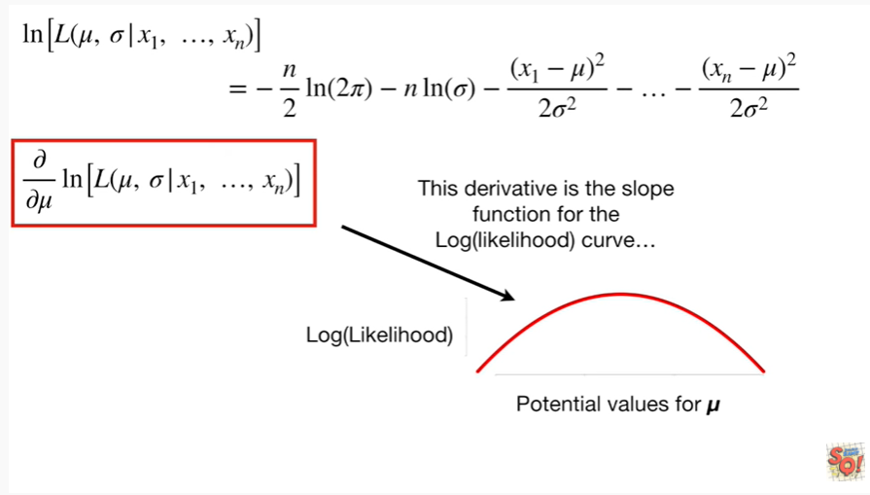

This derivative is the slope function for the log of the likelihood curve

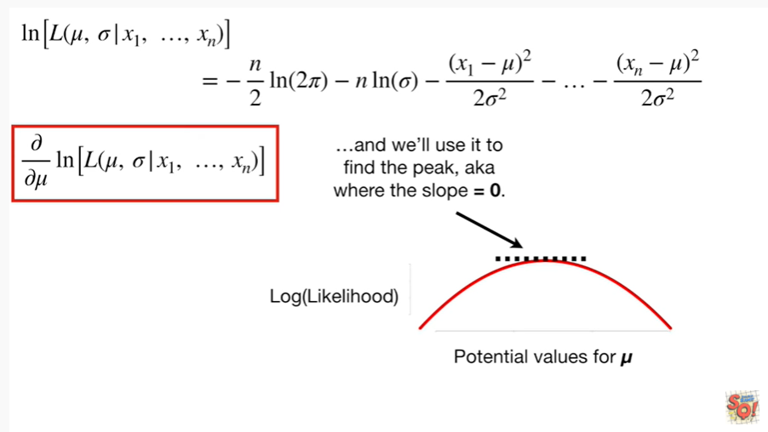

and we'll use it to find the peak aka where the slope equals zero.

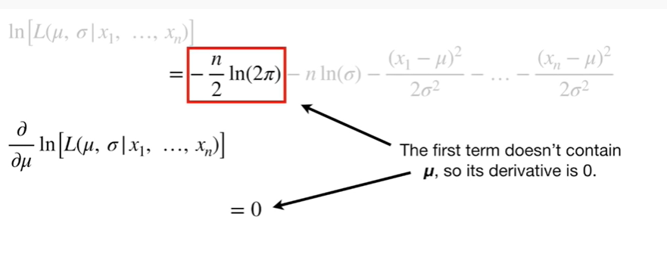

The first term doesn't contain mu so it's derivative is 0.

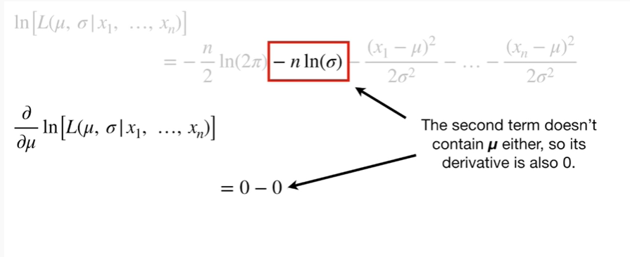

The second term doesn't contain mu either, so it's derivative is also 0.

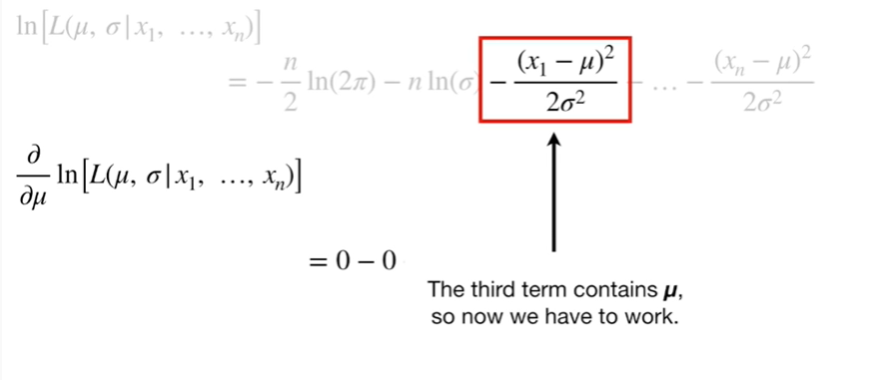

The third term contains mu, so now we have to work.

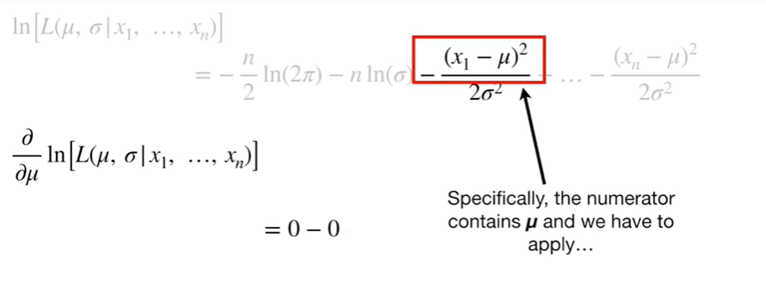

Specifically, the numerator contains mu and we have to apply



the chain.

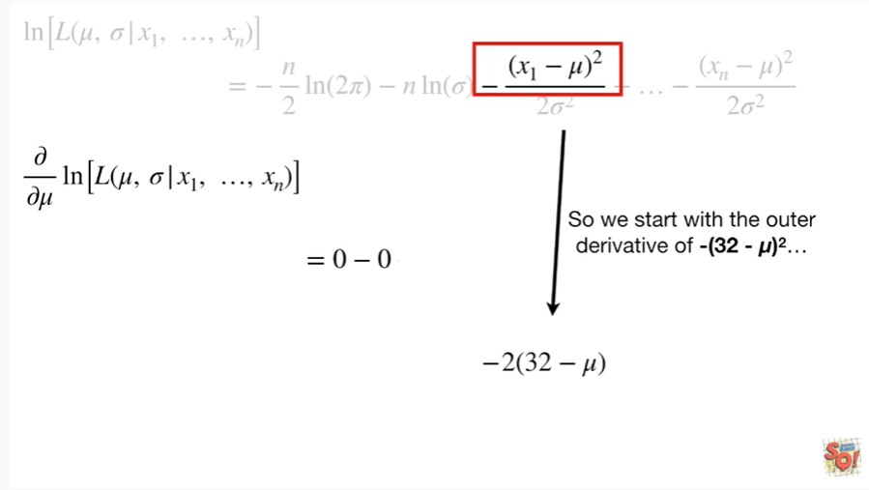

So we start with the outer derivative of negative 32 minus mu squared

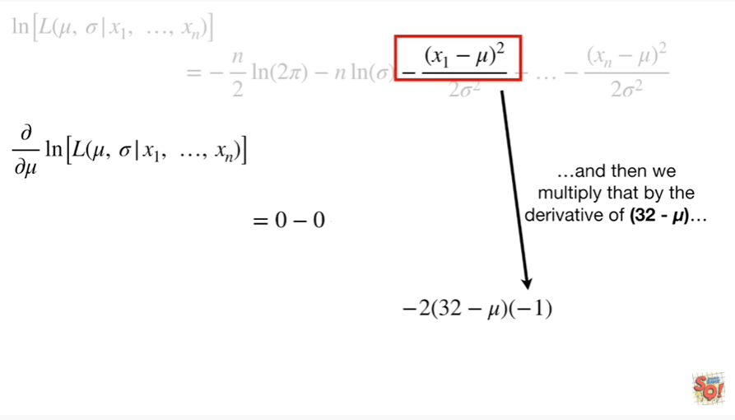

and then we multiply that by the derivative of (32 minus mu)

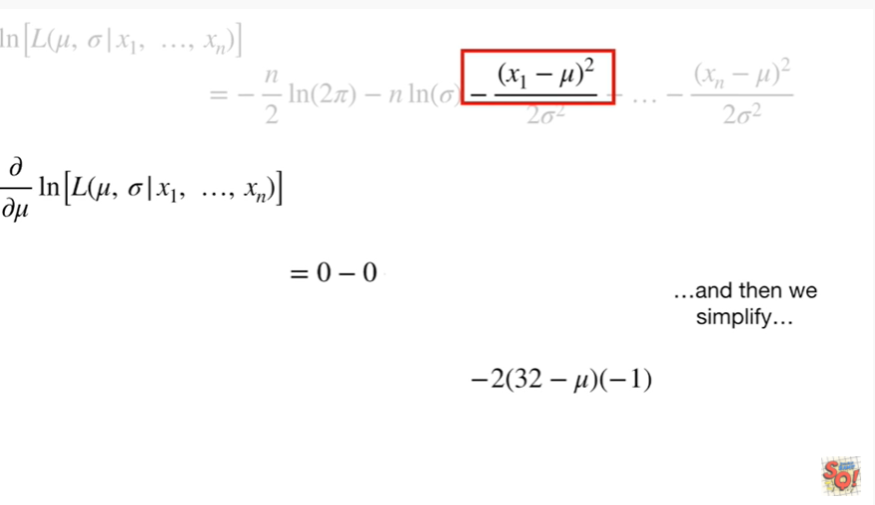

and then we simplify.

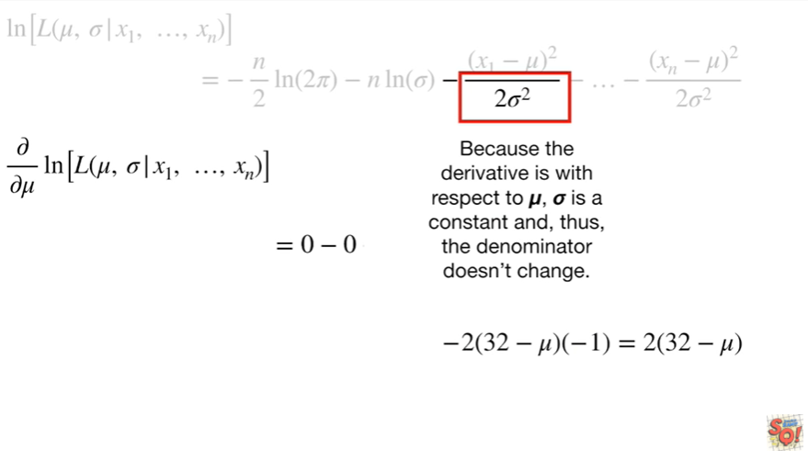

Because the derivative is with respect to MU, Sigma is a constant and, thus the denominator doesn't change

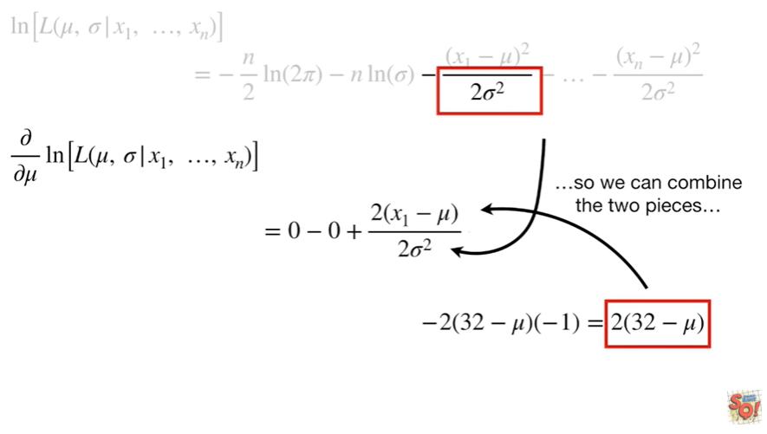

so we can combine the two pieces

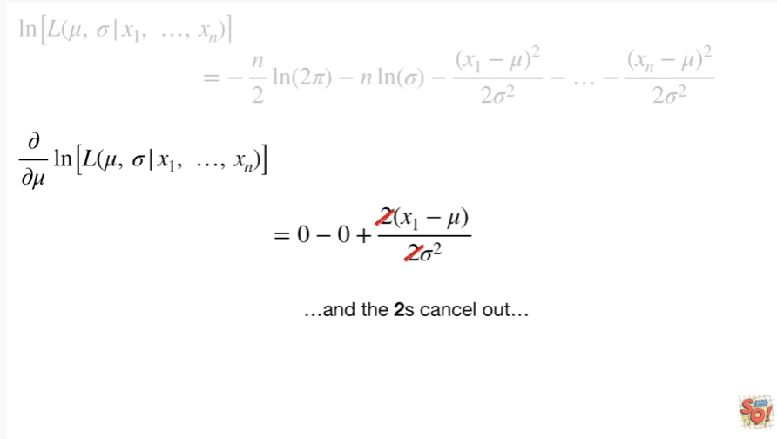

an dthe twos cancel out

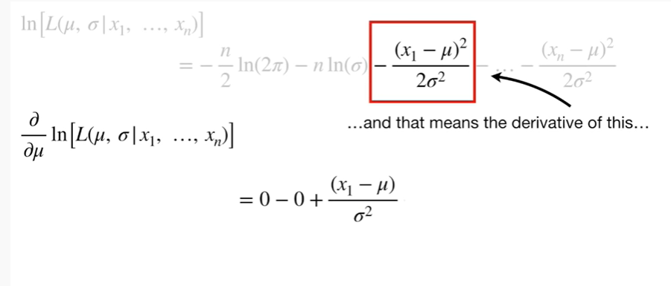

and that means the derivative of this

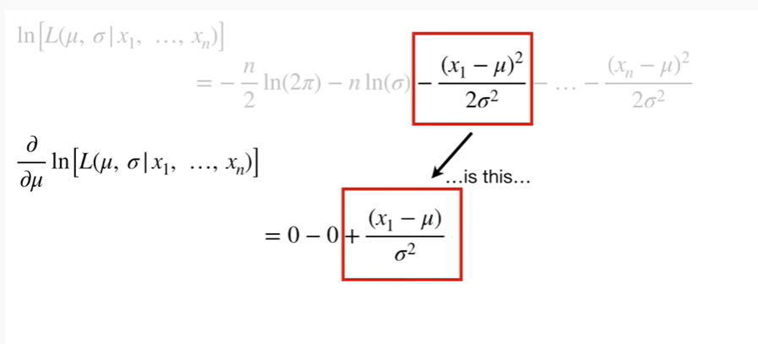

is this.

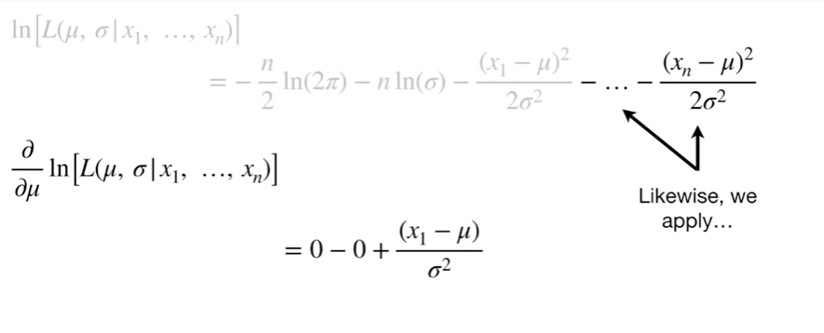

Likewise, we apply



the chain rule

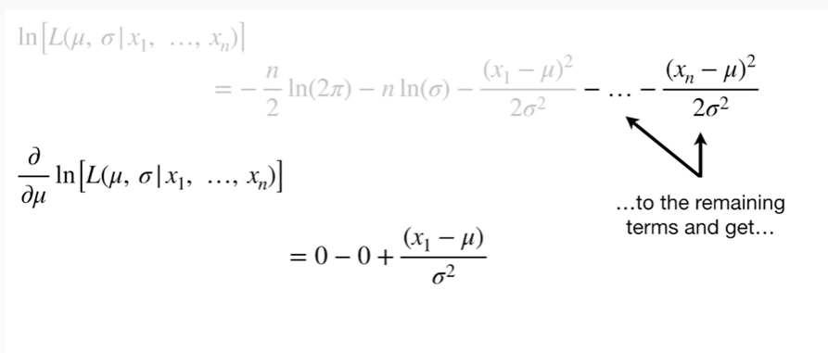

to the remaining terms and get

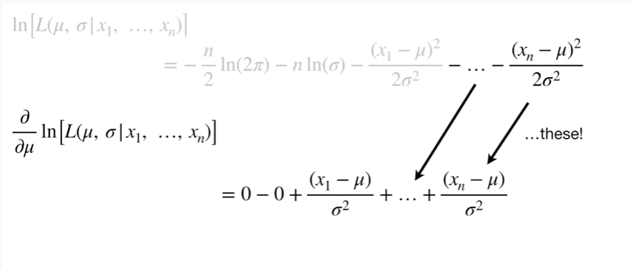

these !

Bam !!!

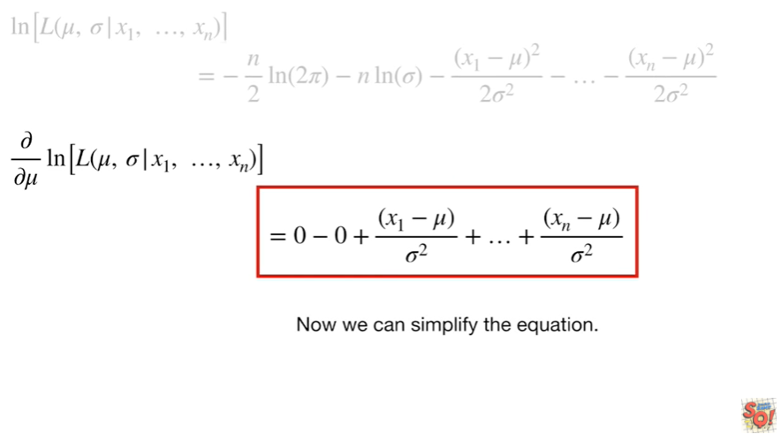

Now we can simplify the equation.

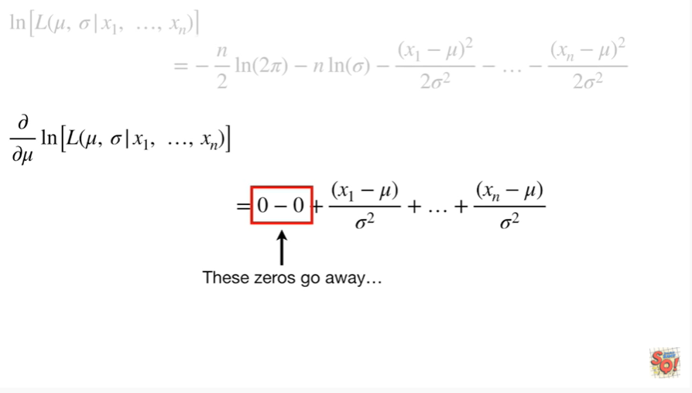

These zeros go away

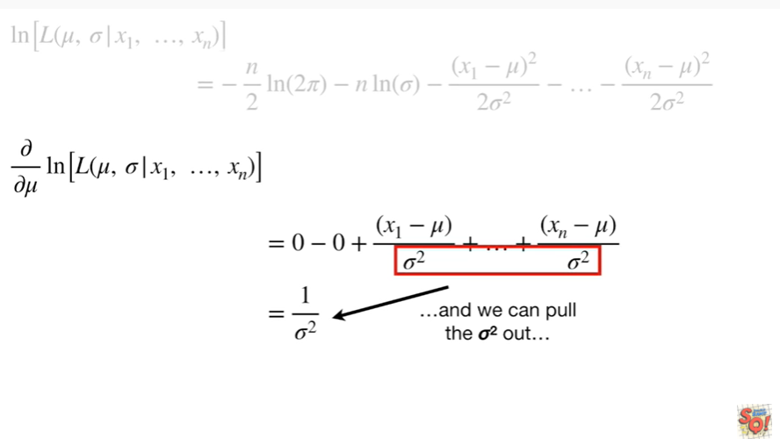

and we can pull the Sigma squared out

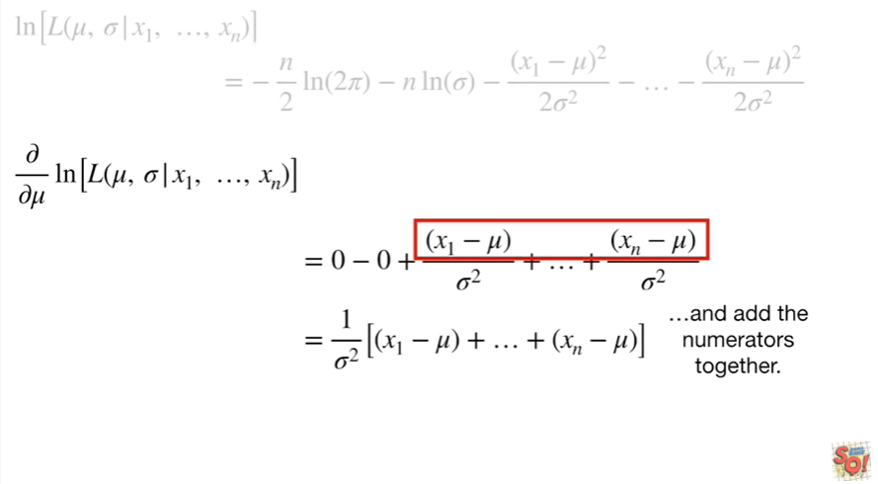

and add the numerators together

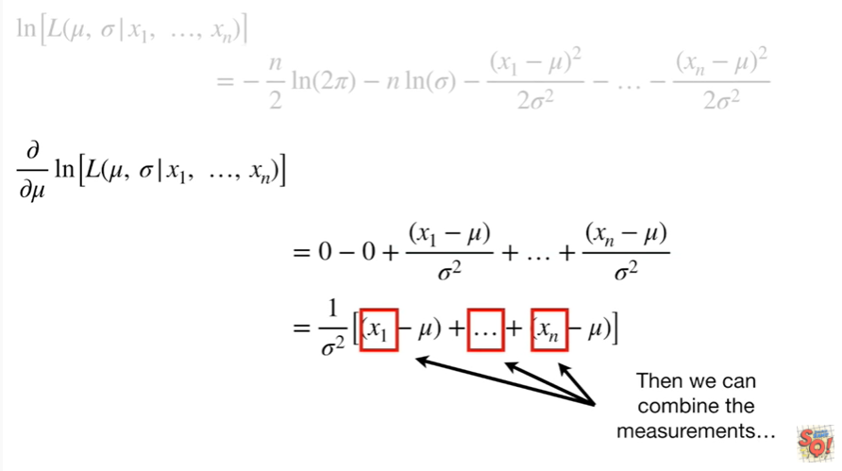

Tthen we can combine the measurements

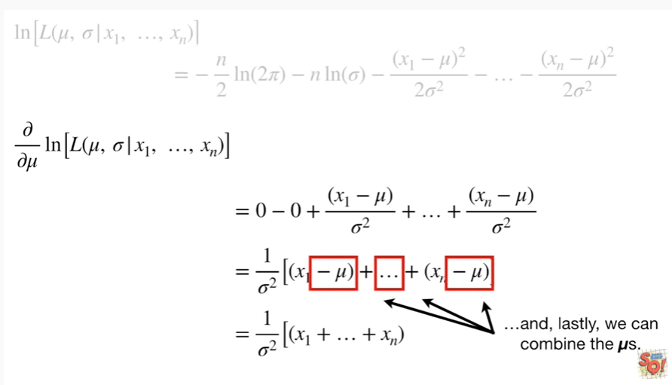

And, lastly, we can combine the mus.

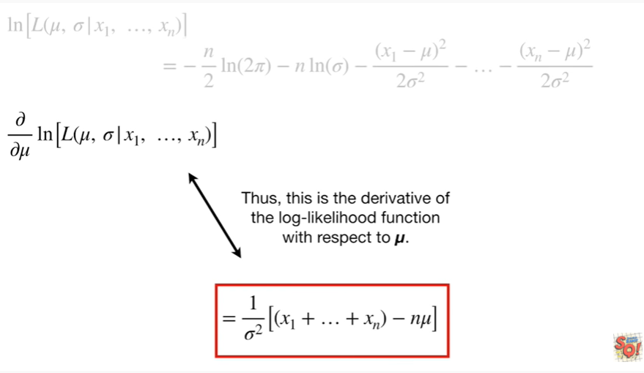

Thus, this is the derivative of the log likelihood function with respect to mu.

Double bam !!!

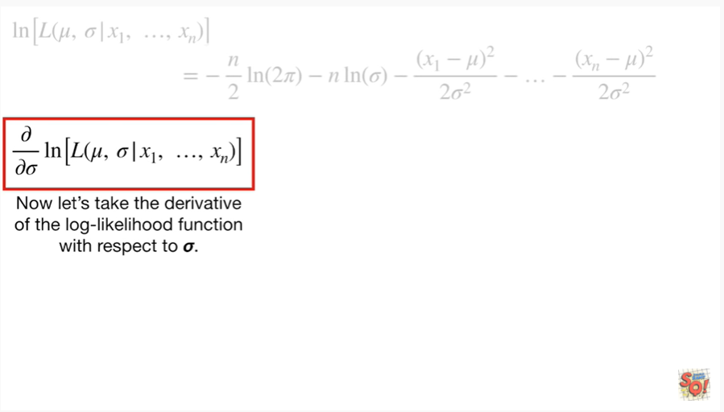

Now let's take the derivative of the log likelihood function with respect to Sigma.

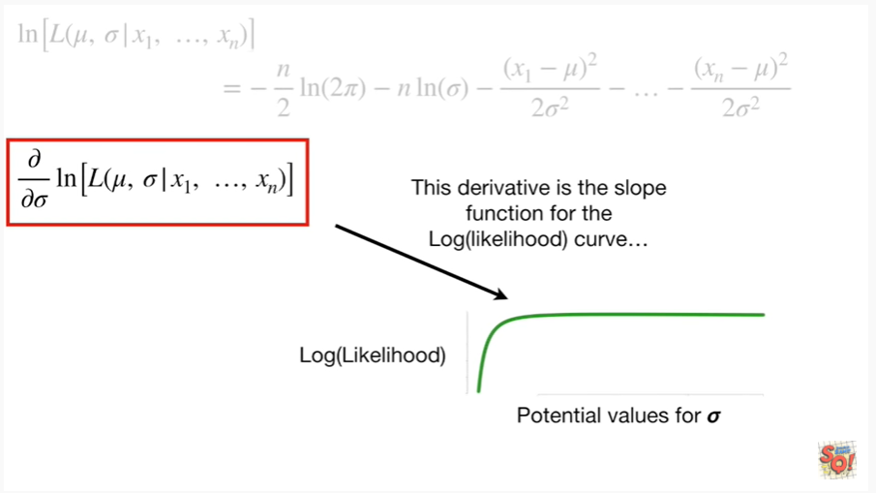

This derivative is the slope function for the log of the likelihood curve

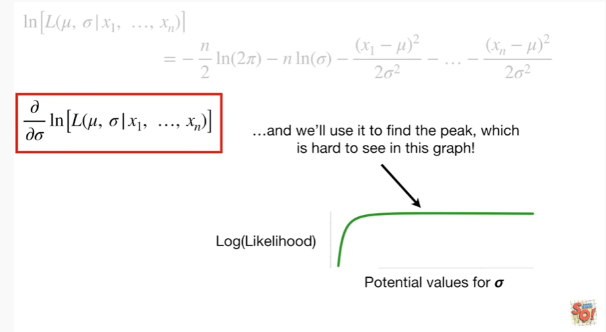

and we'll use it to find the peak, which is hard to see in this graph !

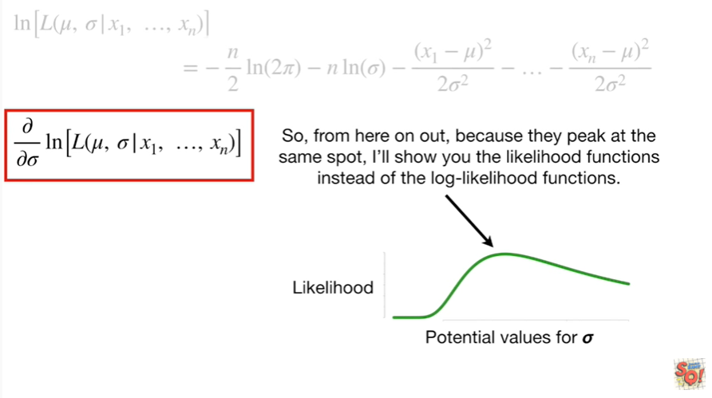

So, from here on out, because they peak at the same spot, I'll show you the likelihood functions instead of the log likelihood functions.

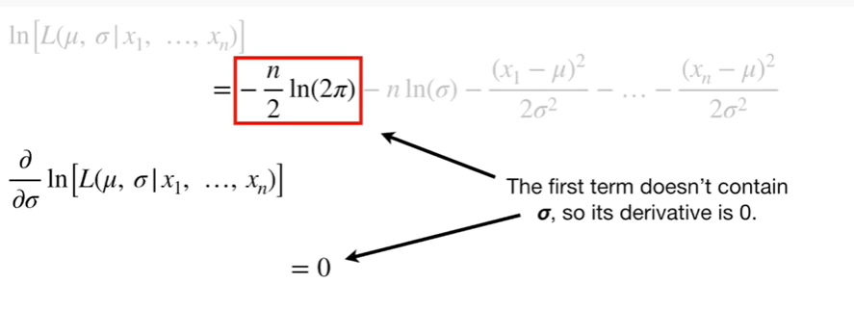

The first term doesn't contain Sigma so it's derivative is zero.

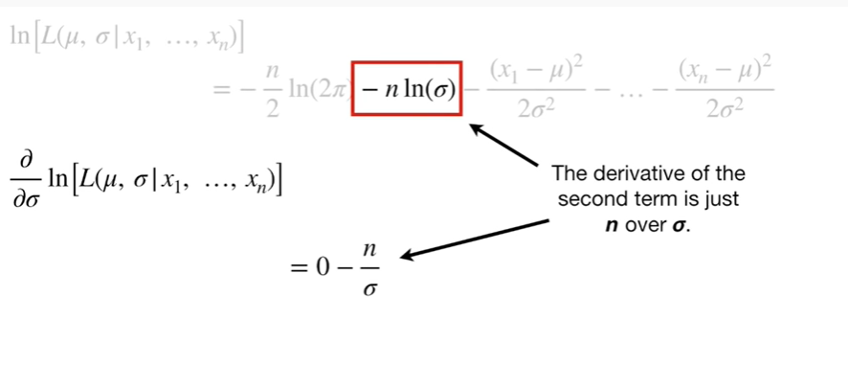

The derivative of the second term is just in over Sigma.

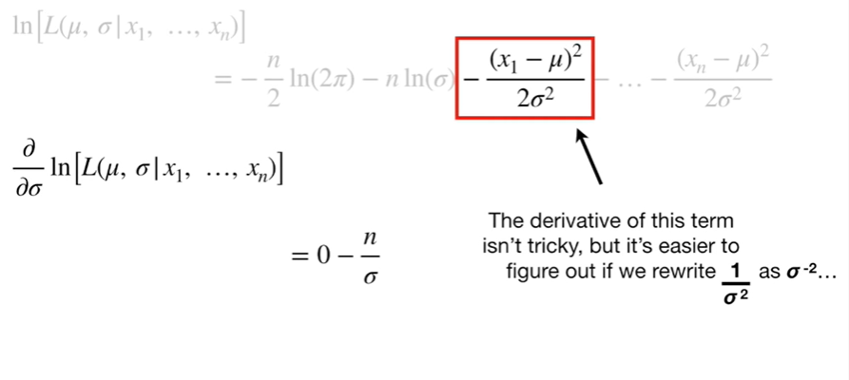

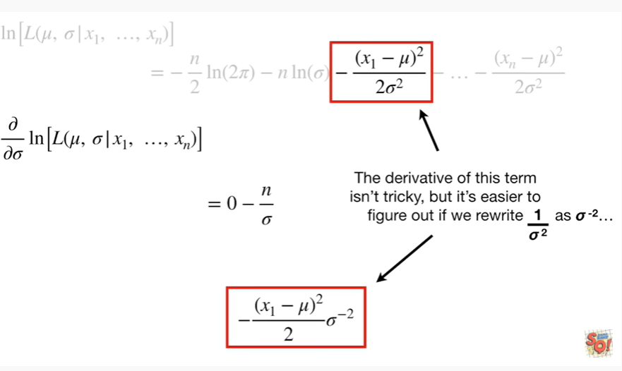

The derivative of this term isn't tricky, but it's easier to figure out when we rewrite 1 over Sigma squared as Sigma to the negative 2.

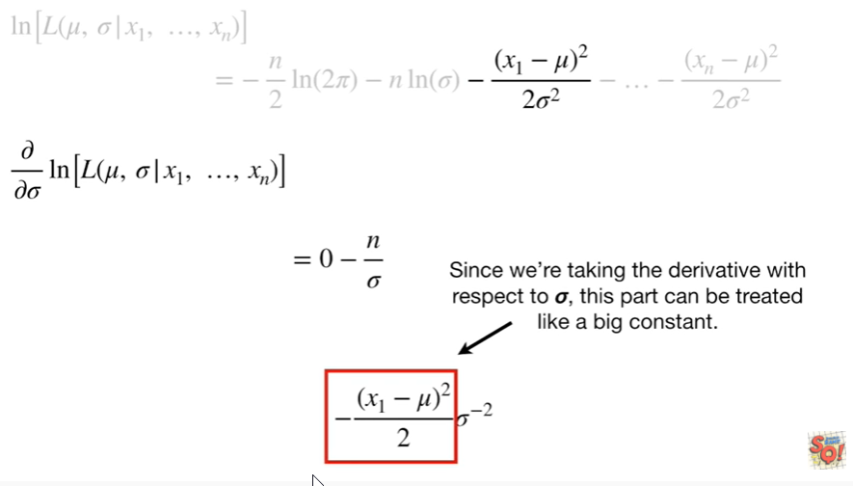

Since we're taking the derivative with respect to Sigma, this part can be treated like a big constant

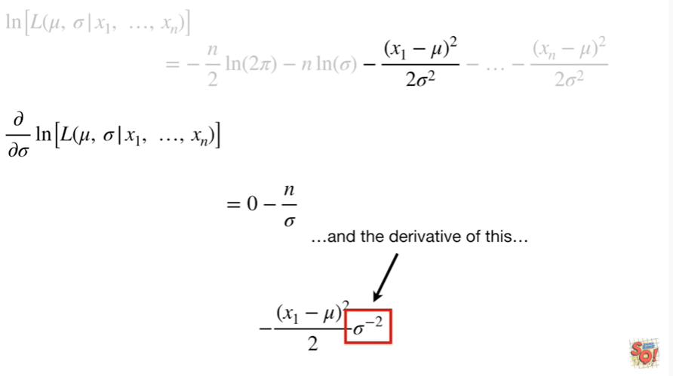

and the derivative of this

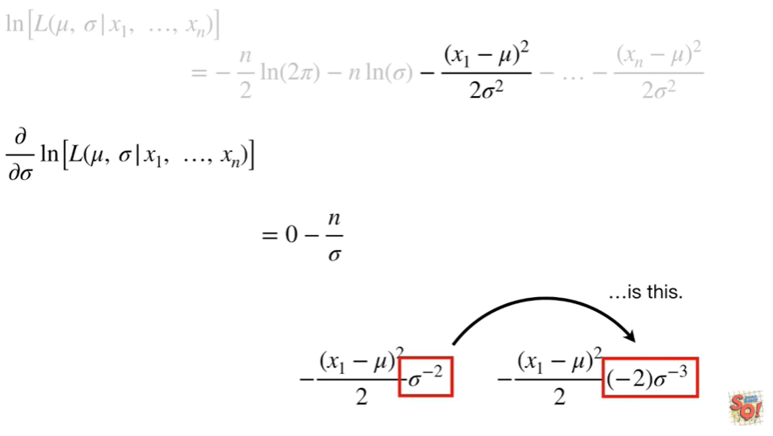

is this.

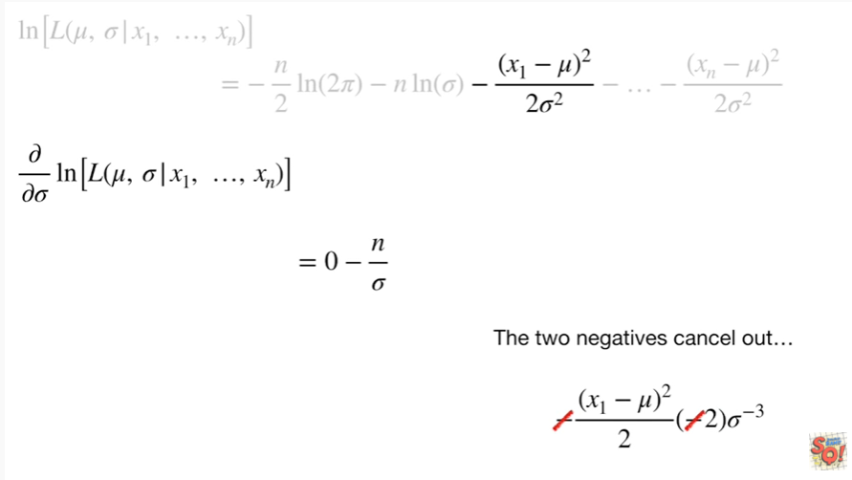

The two negatives cancel out

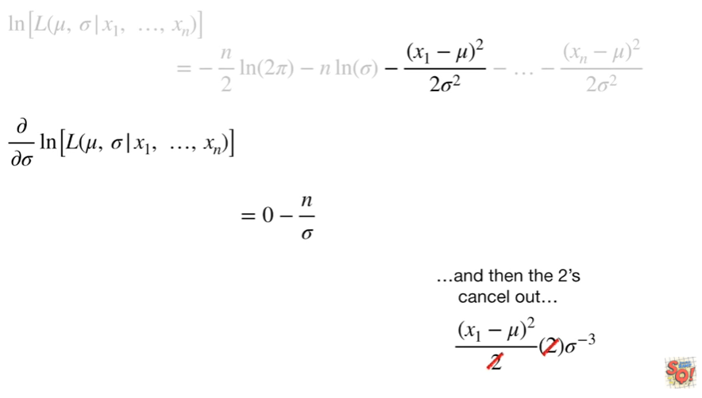

and then the twos cancel out

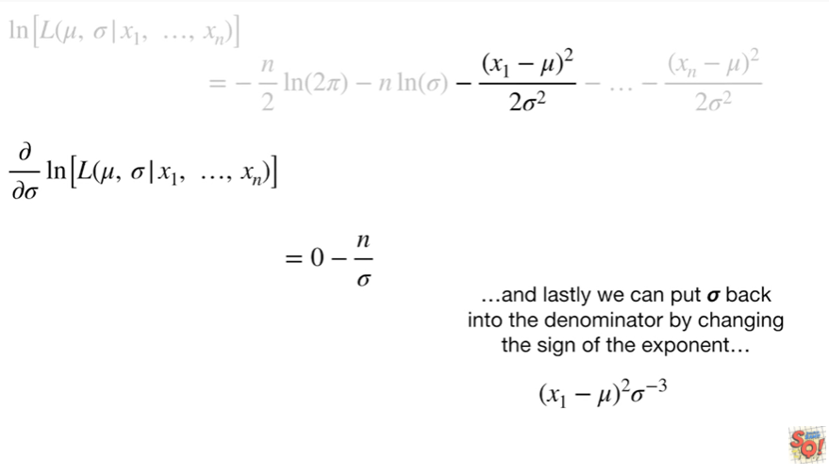

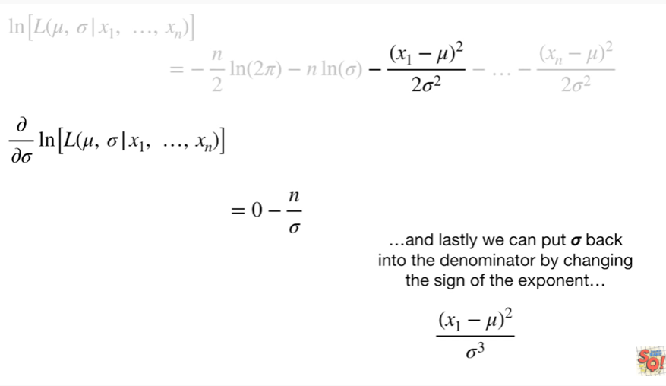

and lastly we put Sigma back into the denominator by changing the sign of the exponent.

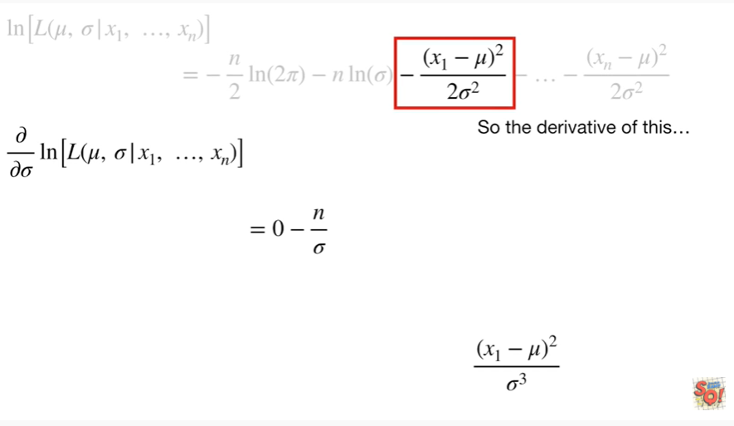

So the derivative of this

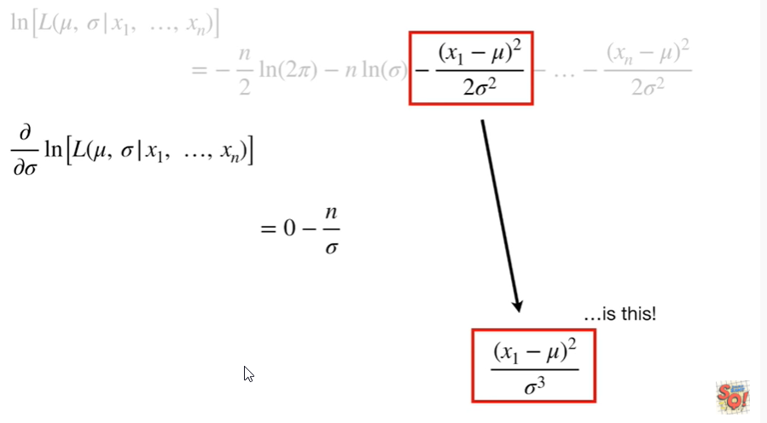

is this !

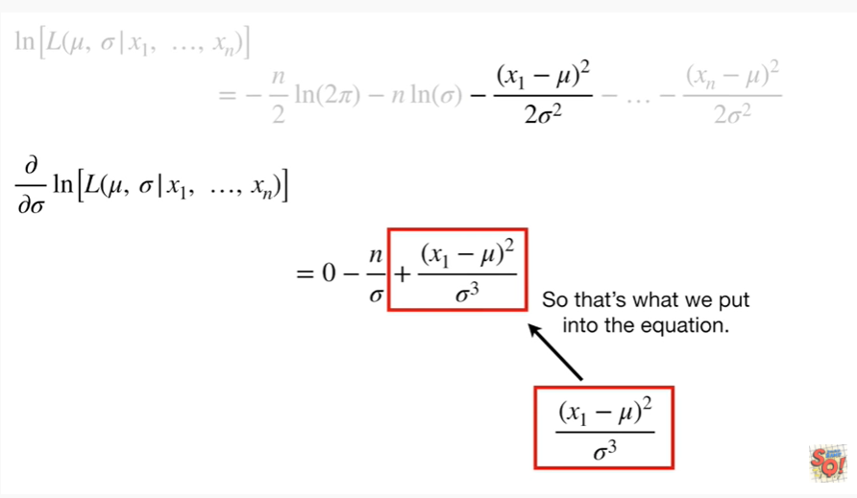

So that's what we put into the equation.

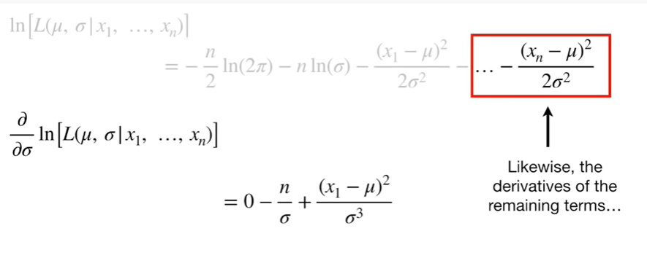

Likewise, the derivatives of the remaining terms

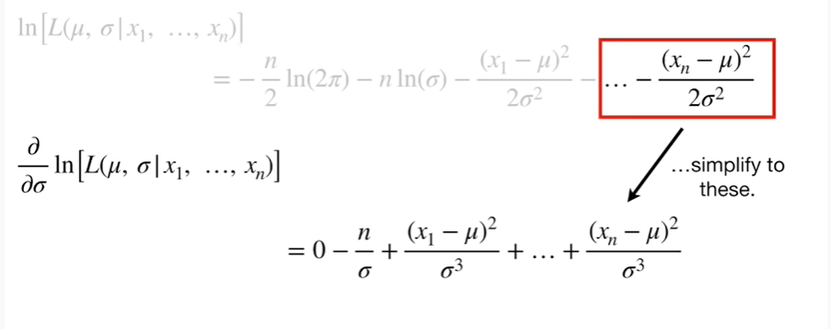

simplify to these.

BAM !!!

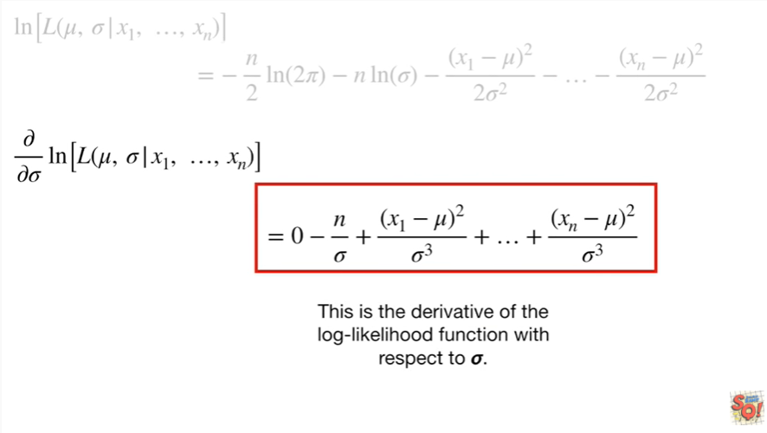

This is the derivative of the log likelihood function with respect to Sigma.

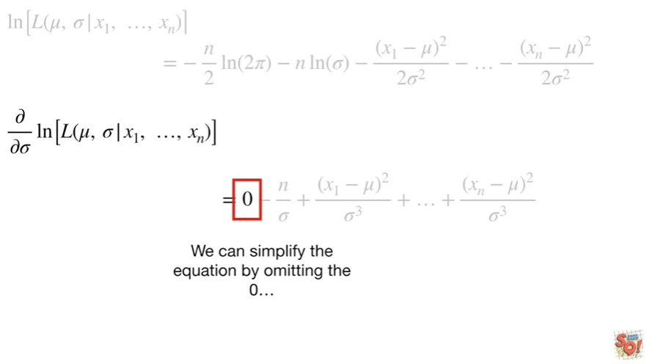

We can simplify the equation by omitting the zero

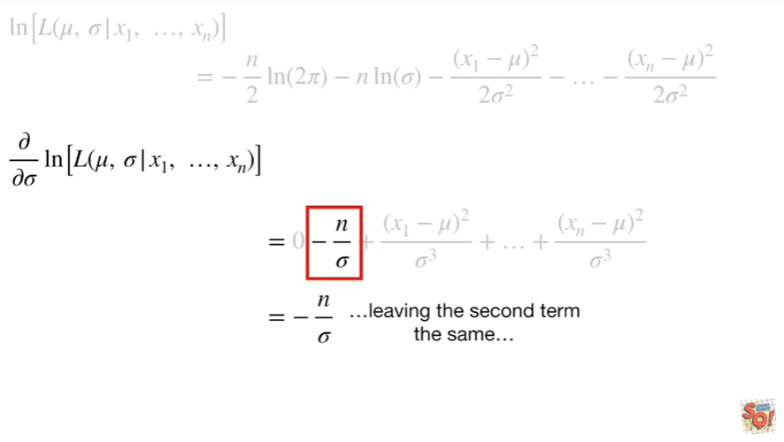

leaving the second term the same

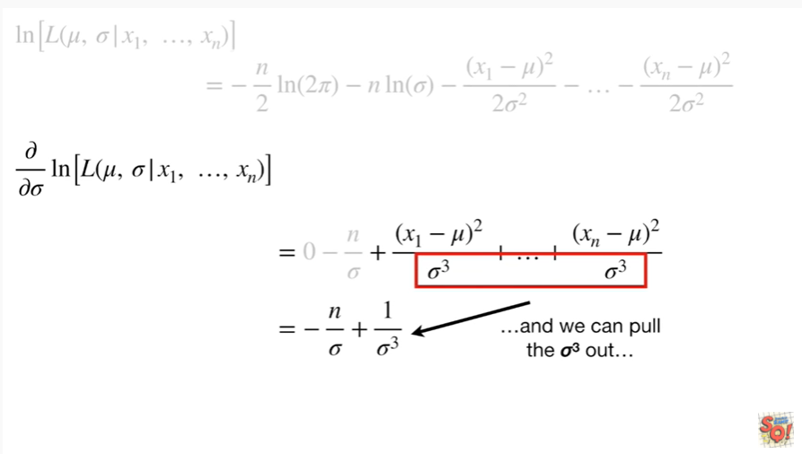

and we can pull the Sigma cubed out

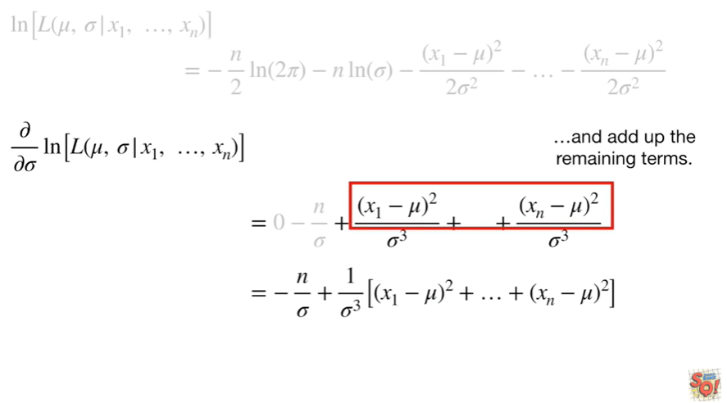

and add up the remaining terms.

Double bam !!!

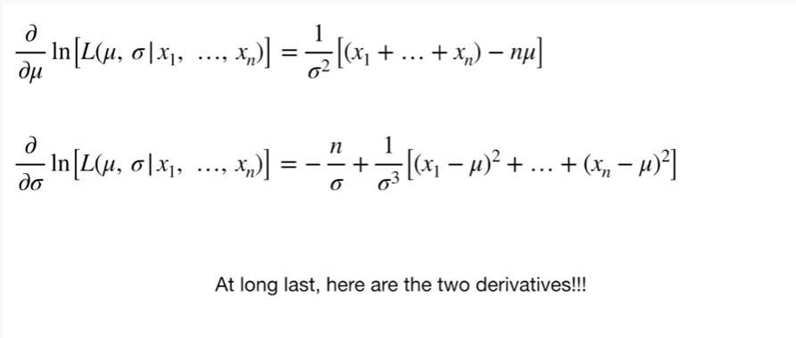

At long last here are the two derivatives !!!

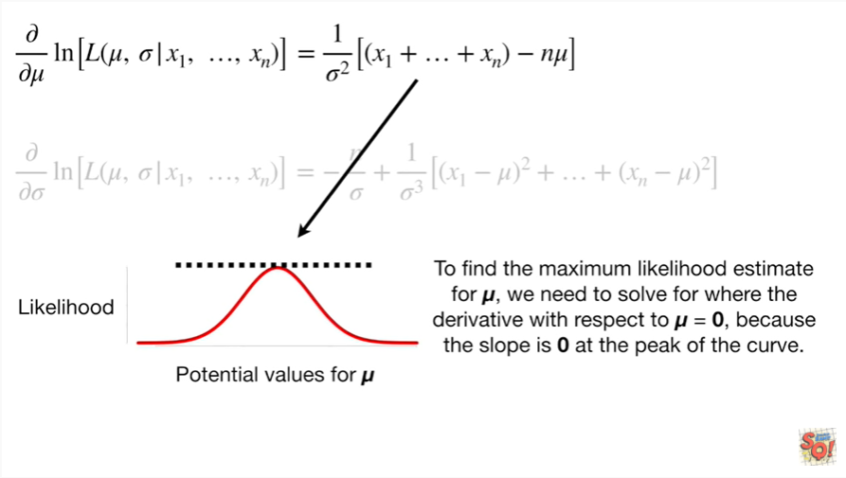

To find the maximum likelihood estimate for MU we need to solve for where the derivative with respect to MU equals zero, because the slope is zero at the peak of the curve.

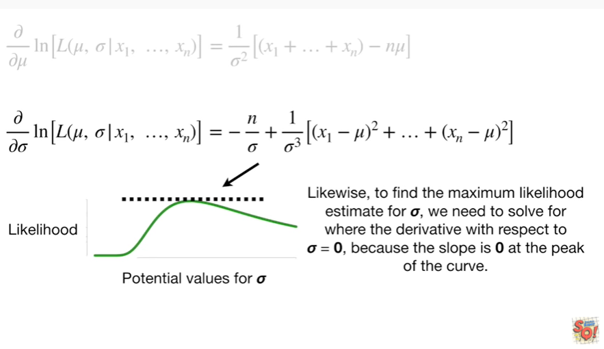

Likewise, to find the maximum likelihood estimate for Sigma, we need to solve for where the derivative with respect to Sigma equals zero because the slope is zero at the peak of the curve.

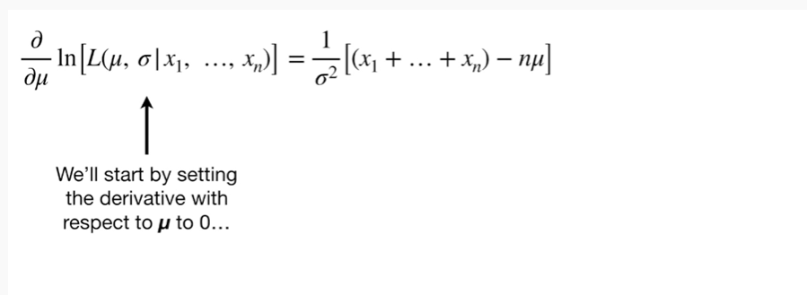

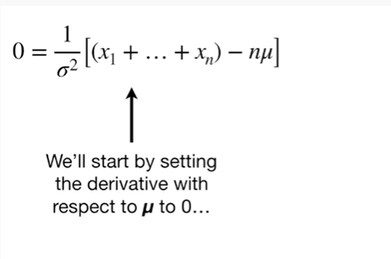

We'll start by setting the derivative with respect to MU to 0

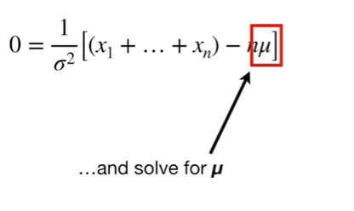

and solve for MU.

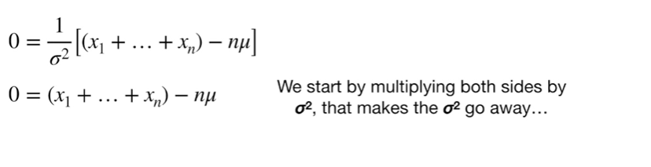

We start by multiplying both sides by Sigma squared that makes the Sigma squared go away

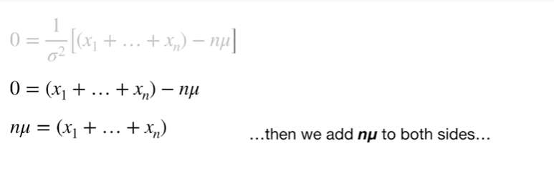

then we add n times mu to both sides

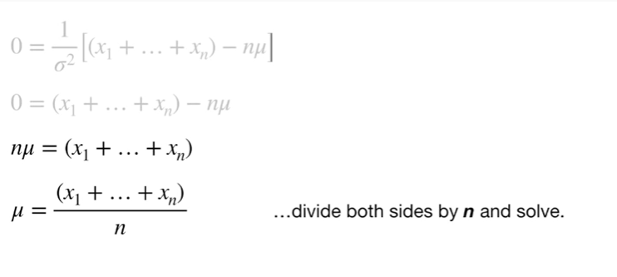

divide both sides by N and solve.

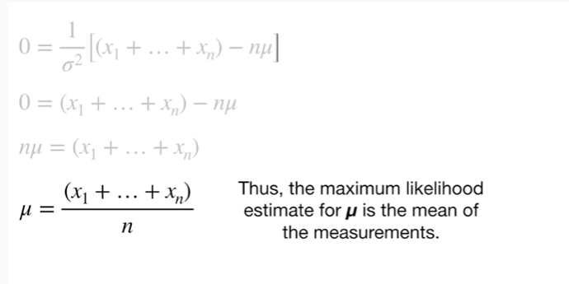

Thus, the maximum likelihood estimate for MU is the mean of the measurements.

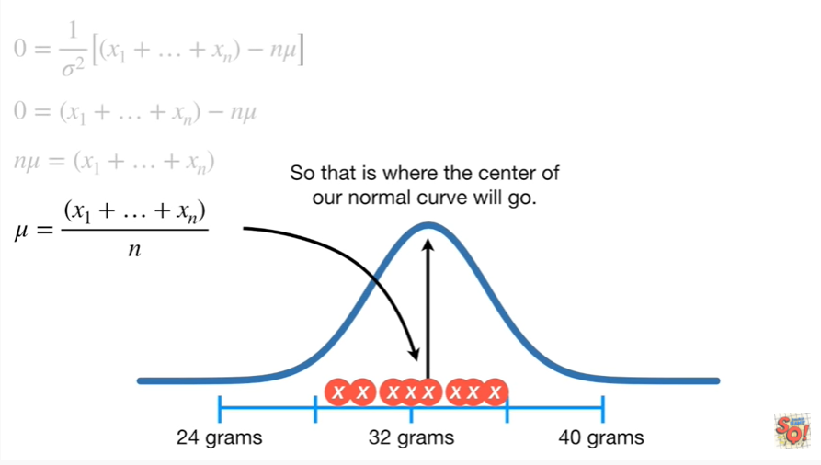

So that is where the center of our normal curve will go.

Don't get too excited, we're not done yet !

Dang !!

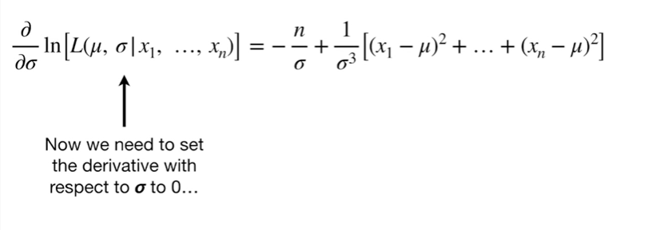

Now we need to set the derivative with respect to Sigma to 0.

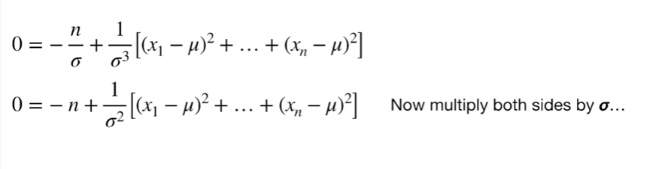

Now multiply both sides by Sigma

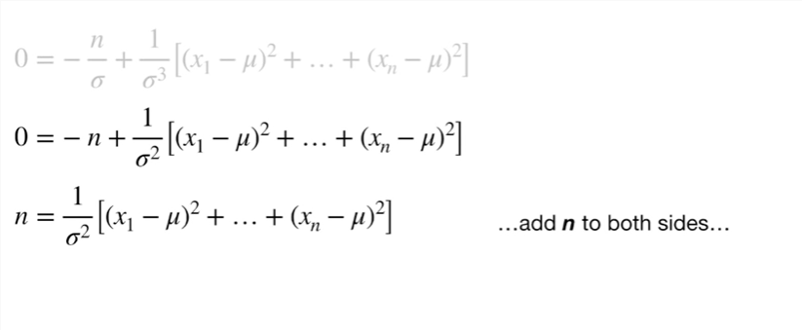

add n to both sides

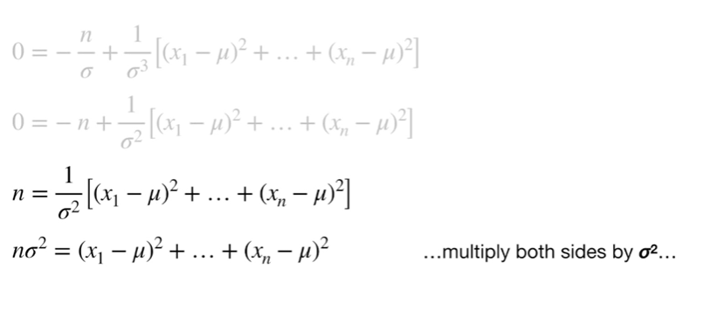

multiply both sides by Sigma squared

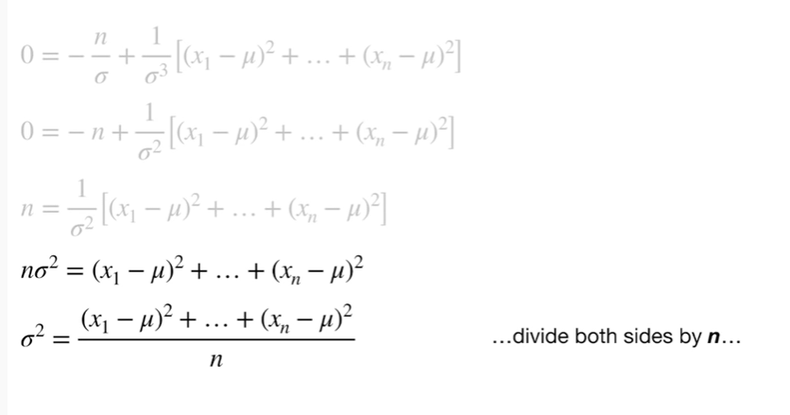

divide both sides by n

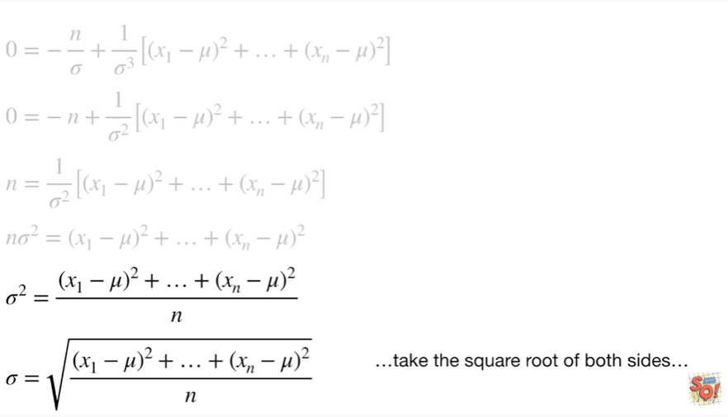

and take the square root of both sides

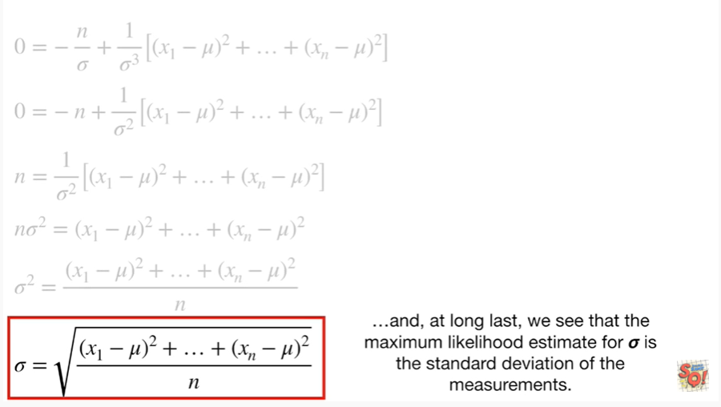

and at long last we see that the maximum likelihood estimate for Sigma is the standard deviation of the measurements.

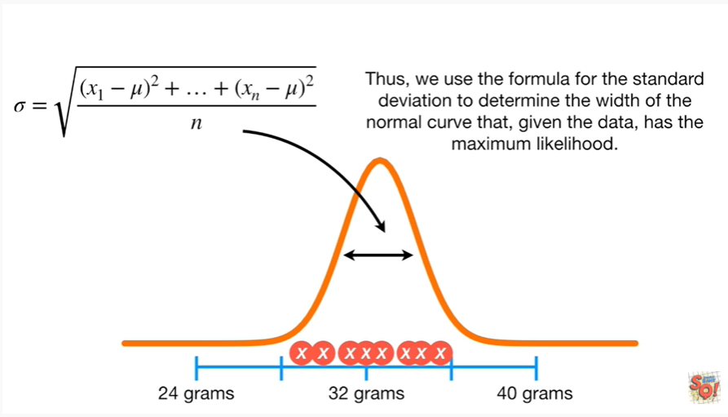

Thus, we use the formula for the standard deviation to determine the width of the normal curve that, given the data, has the maximum likelihood.

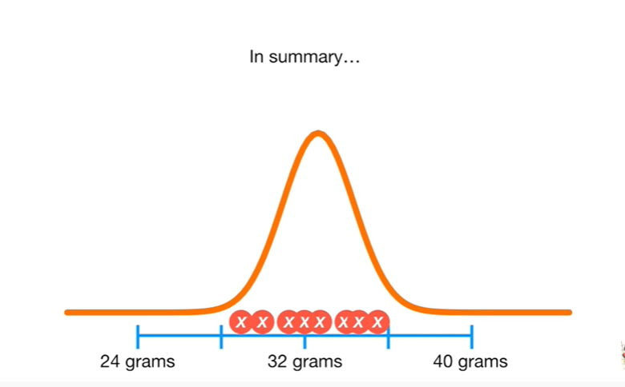

In summary :

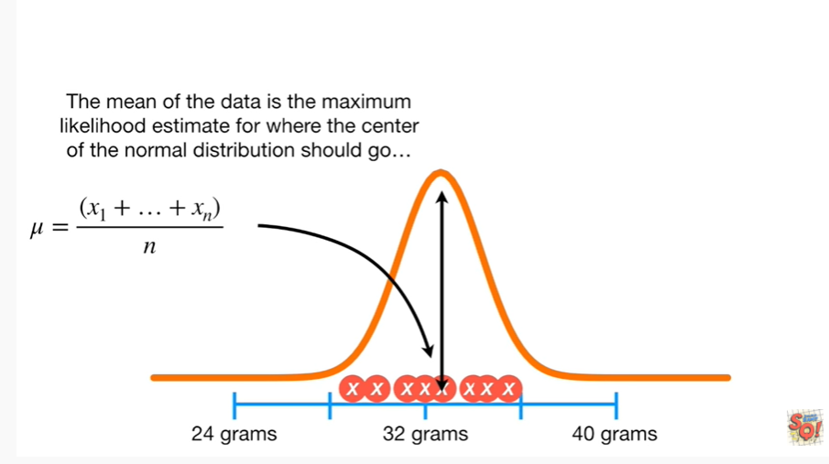

the mean of the data is the maximum likelihood estimate for where the center of the normal distribution should go

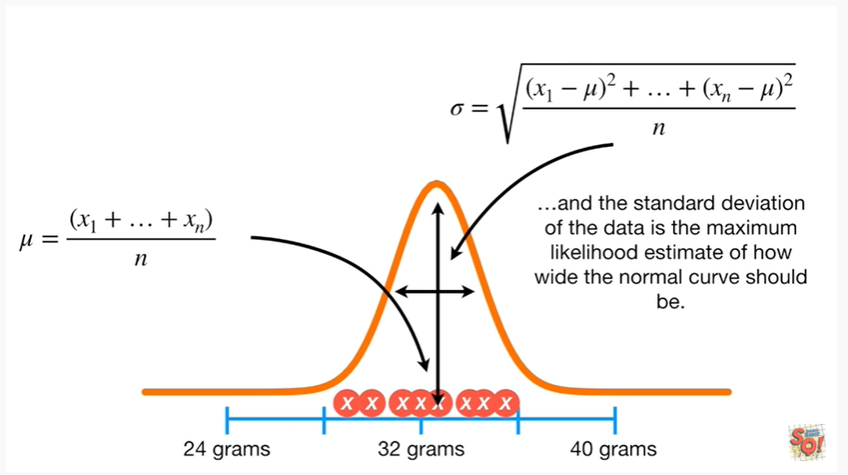

and the standard deviation of the data is the maximum likelihood estimate of how wide the normal curve should be.

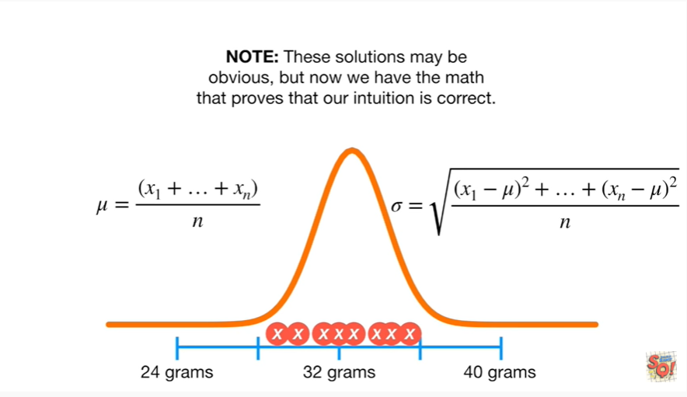

Note : these solutions may be obvious but now we have the math that proves that our intuition is correct.

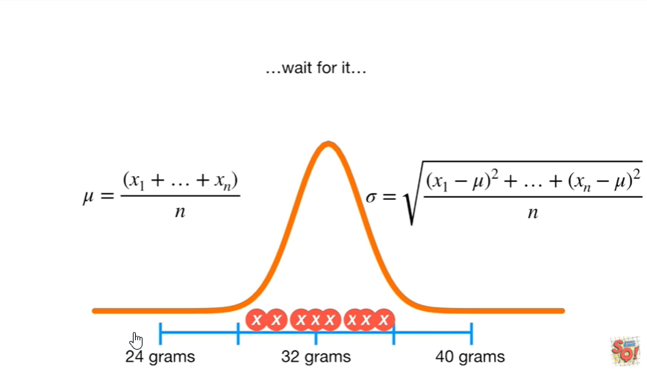

wait for it.

Triple bam !!!